User Manual for InSAR-Based Fault-Crossing Pipeline Displacement and Strain Analysis Tool

Prepared By

University of California, Berkeley

Youqi Zhang, youqi.zhang@berkeley.edu

Matthew De Jong, dejong@berkeley.edu

Tianyu Han, tyhan@berkeley.edu

Release date: August, 2026

Table of Contents

1. Application Overview 3
1.1 Purpose of the Software 3
1.2 Intended Users 3
1.3 Main Capabilities 3
1.4 Workflow (Step 1 to Step 4) 4
1.5 Analysis Scope and Limitations 5
2. Quick Start Guide 5
4. User Interface Layout 7
4.2 Date and Coordinate-System Selectors 11
4.3 Fit Tab Interaction Elements 11
5. Input Data 12
5.1 Required Input Files 12
5.2 InSAR Data Requirements 13
6. Core Analysis Workflow 13
6.1 Workflow Overview 13
6.2 Step 1: Solve Ground Motion 13
6.3 Step 2: Fit Shape Function 15
6.4 Step 3: Estimate Pipeline Displacement 15
6.5 Step 4: Estimate Pipeline Strain 17
7. Fit Controls and Advanced Fitting Tools 19
7.1 Fit Controls in the Workflow 19
7.2 Fit Override (Manual Parameter Control) 20
7.3 Interpreting Sigmoid Parameters (a, b, c, d) 21
7.4 Fit Data Mode and Direction Context 21
7.5 Sigmoid b Enhancement: Purpose 21
8. Soil–Structure Interaction (SSI) 25
9. Export, State, and Reproducibility 26
10. Logs and Performance 27
11. Glossary 28
11.1 Core Analysis Terms 28
11.2 Fitting and Model Terms 28
11.3 Uncertainty Terms 29
11.4 Sigmoid b Enhancement Terms 30
11.5 SSI Terms 30
11.6 Displacement and Strain Terms 31
11.7 Export and State Terms 31

1. Application Overview

1.1 Purpose of the Software
The InSAR Fault-Pipeline Strain GUI is an analysis tool for estimating pipeline displacement and strain induced by fault-related ground deformation derived from paired ascending/descending InSAR observations. The software provides a structured, step-based workflow to transform geospatial observations and fault/pipeline geometry into pipeline displacement and strain, and export to downstream risk workflows using OpenSRA https://peer.berkeley.edu/opensra-home1 .

The application is designed to:
- solve 3D ground displacement components from matched InSAR observations,
- fit sigmoid shape functions that represent displacement trends relative to fault geometry,
- estimate pipeline displacement and strain distributions
- visualize results and export them to OpenSRA to update risk assessment.

1.2 Intended Users
This software is intended for engineers and technical analysts working in geotechnical earthquake engineering, geospatial processing, and infrastructure risk assessment.

1.3 Main Capabilities
Key capabilities of the current version include:
- Stepwise analysis workflow: Step 1 (ground motion), Step 2 (fit), Step 3 (pipeline displacement), Step 4 (pipeline strain).
- Dual coordinate representations:
  - Fault-aligned components (Fault-parallel/perpendicular)
  - Geographic components (North &East (N&E))
- Four-parameter sigmoid fitting (a, b, c, d) with override support.
- Epistemic uncertainty propagation through b16 / b50 / b84 cases.
- Sigmoid b Enhancement workflow:
  - sliding-window local fitting,
  - outlier detection,
  - aggregation estimation,
  - one-click application of recommended b values.
- Optional SSI modeling for pipe-soil displacement response.
- Interactive and field visualizations across map, fit, displacement, and strain tabs.
- Export workflows:
  - Export All Results (arrays/tables/figures),
  - Export Results for OpenSRA (mesh-based shapefile with strain-rate attributes).
- State persistence through Save/Load State for reproducible reruns.

1.4 Workflow (Step 1 to Step 4)
The standard analysis flow is:
- Step 1 – Solve Ground Motion
Import and preprocess InSAR/fault/pipeline inputs, match data pairs, and compute 3D displacement components.
- Step 2 – Fit Shape Function
Fit displacement–distance relationships (sigmoid functions) in selected fitting subset data.
- Step 3 – Estimate Pipeline Displacement
Predict pipeline displacement using fitted functions, with optional SSI effects and uncertainty envelopes.
- Step 4 – Estimate Pipeline Strain
Compute axial and bending strain responses, with field visualization outputs.

1.5 Analysis Scope and Limitations
This tool is intended for engineering analysis and decision support. Results are sensitive to:
- input data quality and spatial coverage,
- fault trace selection and data distribution in fit-band section,

2. Quick Start Guide
A first run requires the ascending and descending InSAR shapefiles, a fault line shapefile, a pipeline axis geometry file (supporting both shapefile *.shp and numpy file *.npy), and an output directory. Before running, users should confirm that file paths are valid and that CRS settings are consistent with the native coordinate systems of the data.
After launching the GUI, the recommended sequence is to run Step 1, then Step 2, then Step 3, and finally Step 4. This order should be preserved for new analyses and for major configuration changes. If key geometry or CRS settings are changed, rerunning from Step 1 is recommended to avoid mixed-state artifacts.
When Step 2 completes, users should first inspect the Fit tab before proceeding to interpretation in downstream tabs. This is the most important quality checkpoint. If fitted curves are inconsistent with data scatter, Step 3 and Step 4 outputs will likely inherit that issue.
After Step 4, users can review strain plots, inspect field plots, and export results. The software provides two export paths: a general full-result export and a mesh-based OpenSRA shapefile export. Users can also save state and reload it later to continue work without rerunning all steps.

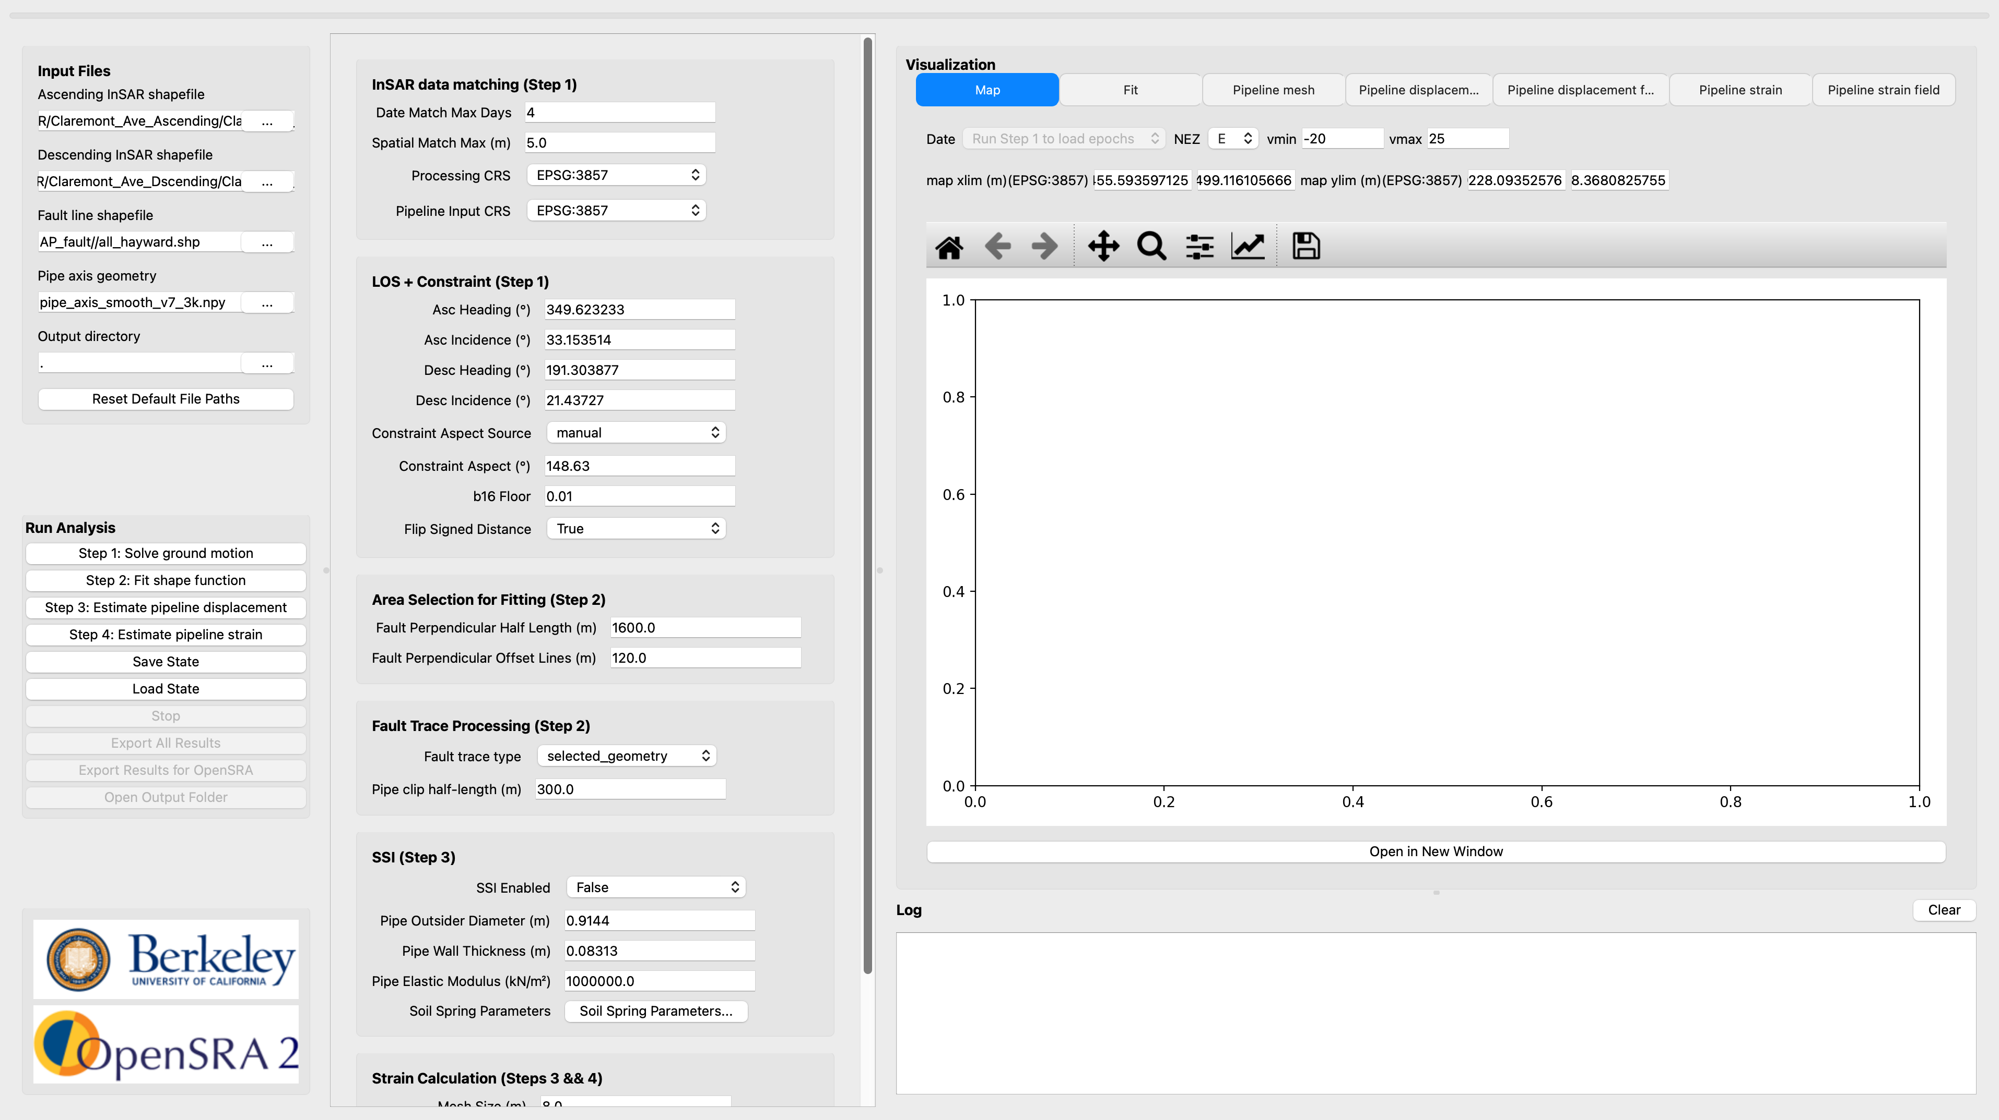

3. Installation and Environment
The current GUI workflow has been developed and validated on both macOS and Windows platforms. To simplify deployment, the entire application and its dependencies are packaged into a standalone executable (an .exe file for Windows and an .app bundle for macOS). No installation or additional configuration is required; users can download the file and launch the application directly.

Recommended baseline:
- 64-bit OS
- Sufficient RAM for geospatial processing and plotting
- Write access to the configured output directory

4. User Interface Layout
The main window is organized into three practical regions. The left side contains file input and run controls. The middle region contains parameter settings. The right side contains visualization tabs and runtime logs.

In the left panel, users define required input files, control step execution, save or load state, and run exports.

In the middle panel, users configure InSAR data matching thresholds, CRS settings, fitting options, fault trace processing, SSI controls, and strain smoothing parameters.

Description of each input parameter:
- Date Match Max Days: Maximum allowed day difference between ascending and descending acquisitions when forming a valid InSAR pair.
- Spatial Match Max (m): Maximum allowed spatial distance to match ascending and descending observation points into one pair.
- Processing CRS: Coordinate reference system used internally for geometry processing, distance calculation, and map-based analysis.
- Pipeline Input CRS: Coordinate reference system for the input pipeline geometry before reprojection to the processing CRS.
- Asc Heading (°): Satellite heading angle of the ascending track used in LOS-to-3D displacement decomposition.
- Asc Incidence (°): Radar incidence angle of the ascending track used in LOS-to-3D displacement decomposition.
- Desc Heading (°): Satellite heading angle of the descending track used in LOS-to-3D displacement decomposition.
- Desc Incidence (°): Radar incidence angle of the descending track used in LOS-to-3D displacement decomposition.
- Constraint Aspect Source: Selects whether the decomposition constraint aspect angle is manually entered or derived from fault geometry.
- Constraint Aspect (°): User-defined horizontal constraint direction angle used when manual constraint aspect is selected.
- b16 Floor: Lower bound threshold below which the 16th-percentile bb case is disabled to avoid nonphysical uncertainty cases.
- Flip Signed Distance: Toggles reversal of the signed-distance direction convention used for fault-side dependent fitting and prediction.
- Fault Perpendicular Half Length (m): Half-length of the fitting transect centered at the fault-pipeline intersection for selecting fitting data.
- Fault Perpendicular Offset Lines (m): Half-width of the fitting band defined by two lines parallel to the transect at this offset distance.
- Fault trace type: Chooses which fault trace representation (selected or fitted) is used for fitting and downstream calculations. The transect used for fitting is defined based on the fault-pipe intersection point. However, because fault traces are often represented as discontinuous line segments, they may not intersect the pipeline directly. In such cases, a fitted fault line is used to ensure a valid intersection with the pipeline, thereby providing a reference point for defining the fitting transect.
- Pipe clip half-length (m): The distance from the fault-pipe intersection to both ends of the pipeline.
- SSI Enabled: Enables or disables the soil-structure interaction solver during pipeline displacement prediction.
- Pipe Outsider Diameter (m): Outer diameter of the pipe used by the SSI model in Step 3 and bending strain estimate in Step 4.
- Pipe Wall Thickness: Pipe wall thickness used by the SSI model to compute section properties and stiffness.
- Pipe Elastic Modulus (kN/m²): Pipe Young’s modulus used by the SSI model to define structural stiffness.
- Soil Spring Parameters: Opens a detailed parameter dialog for configuring soil spring, friction, increment, and solver controls in SSI.
- Mesh Size (m): Target nodal spacing used to discretize pipeline geometry into nodes and beam elements for displacement and strain calculations.
- Axial Smoothing Window: Window size controlling smoothing strength for computed axial strain along the pipeline.
- Bending Sample Step: Sampling stride used when evaluating bending strain along pipeline nodes for noise control.

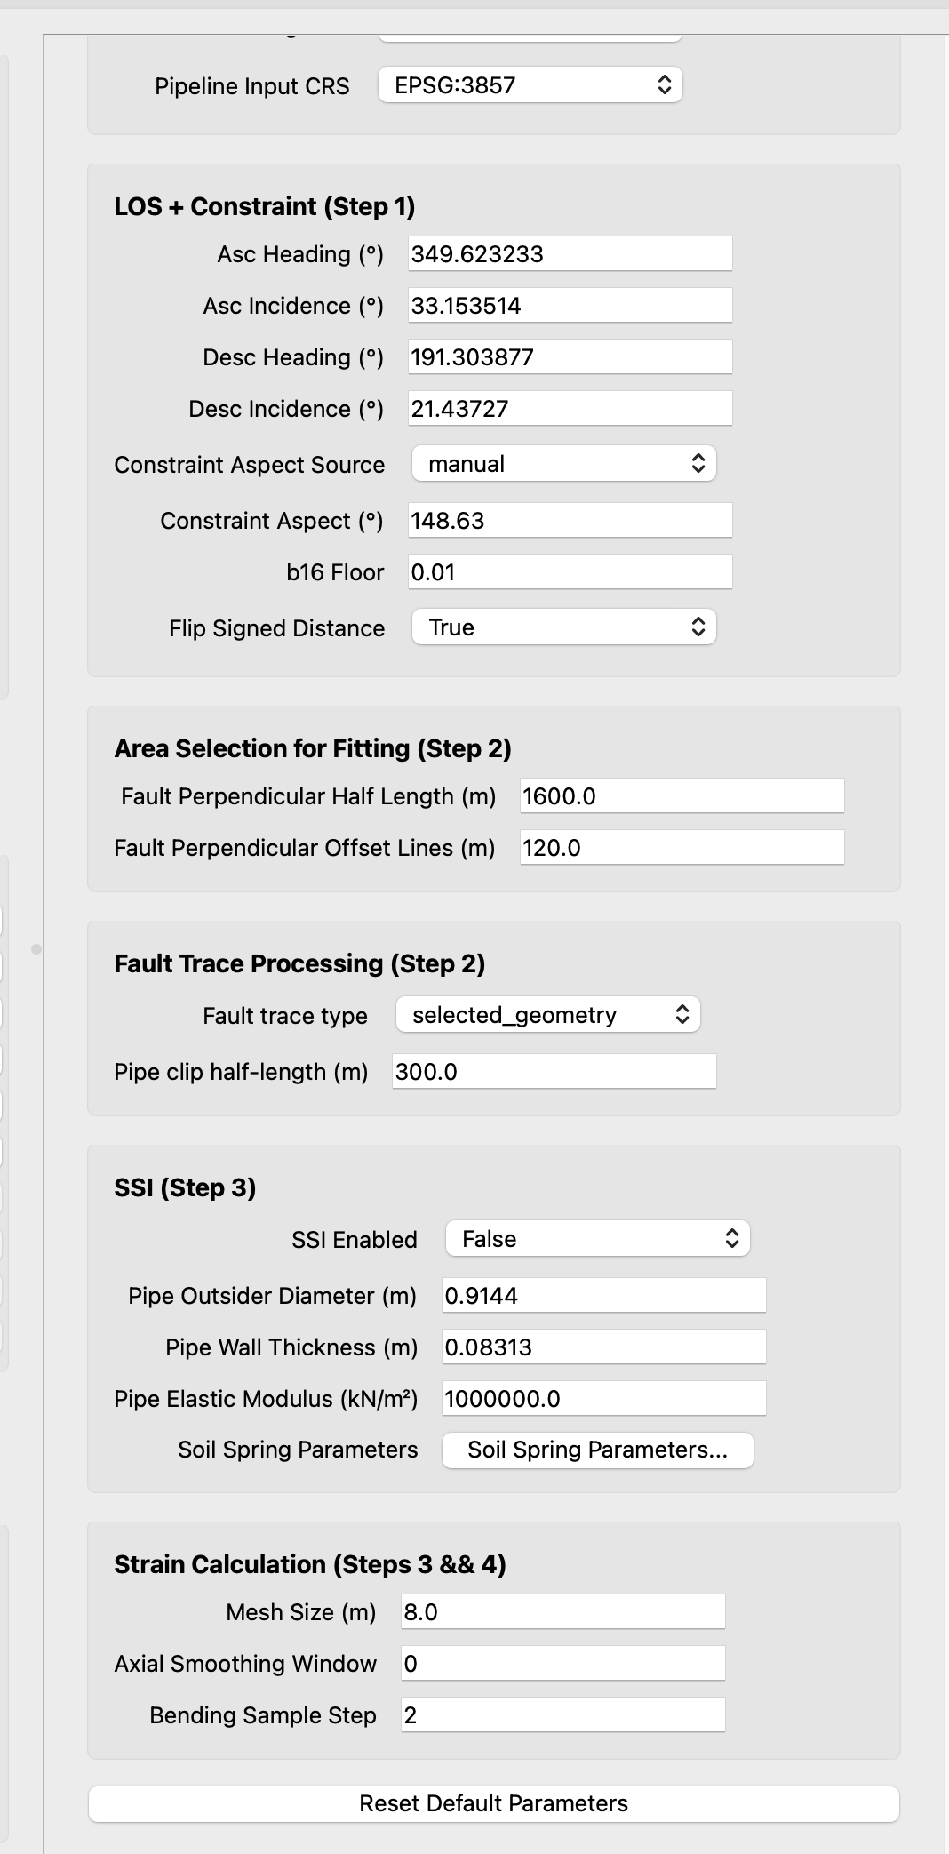

The button “Reset Default Parameters” can reset all the parameters in the middle column to the original default values. This button does not affect the parameters in Visualization panel or the Input Files panel.

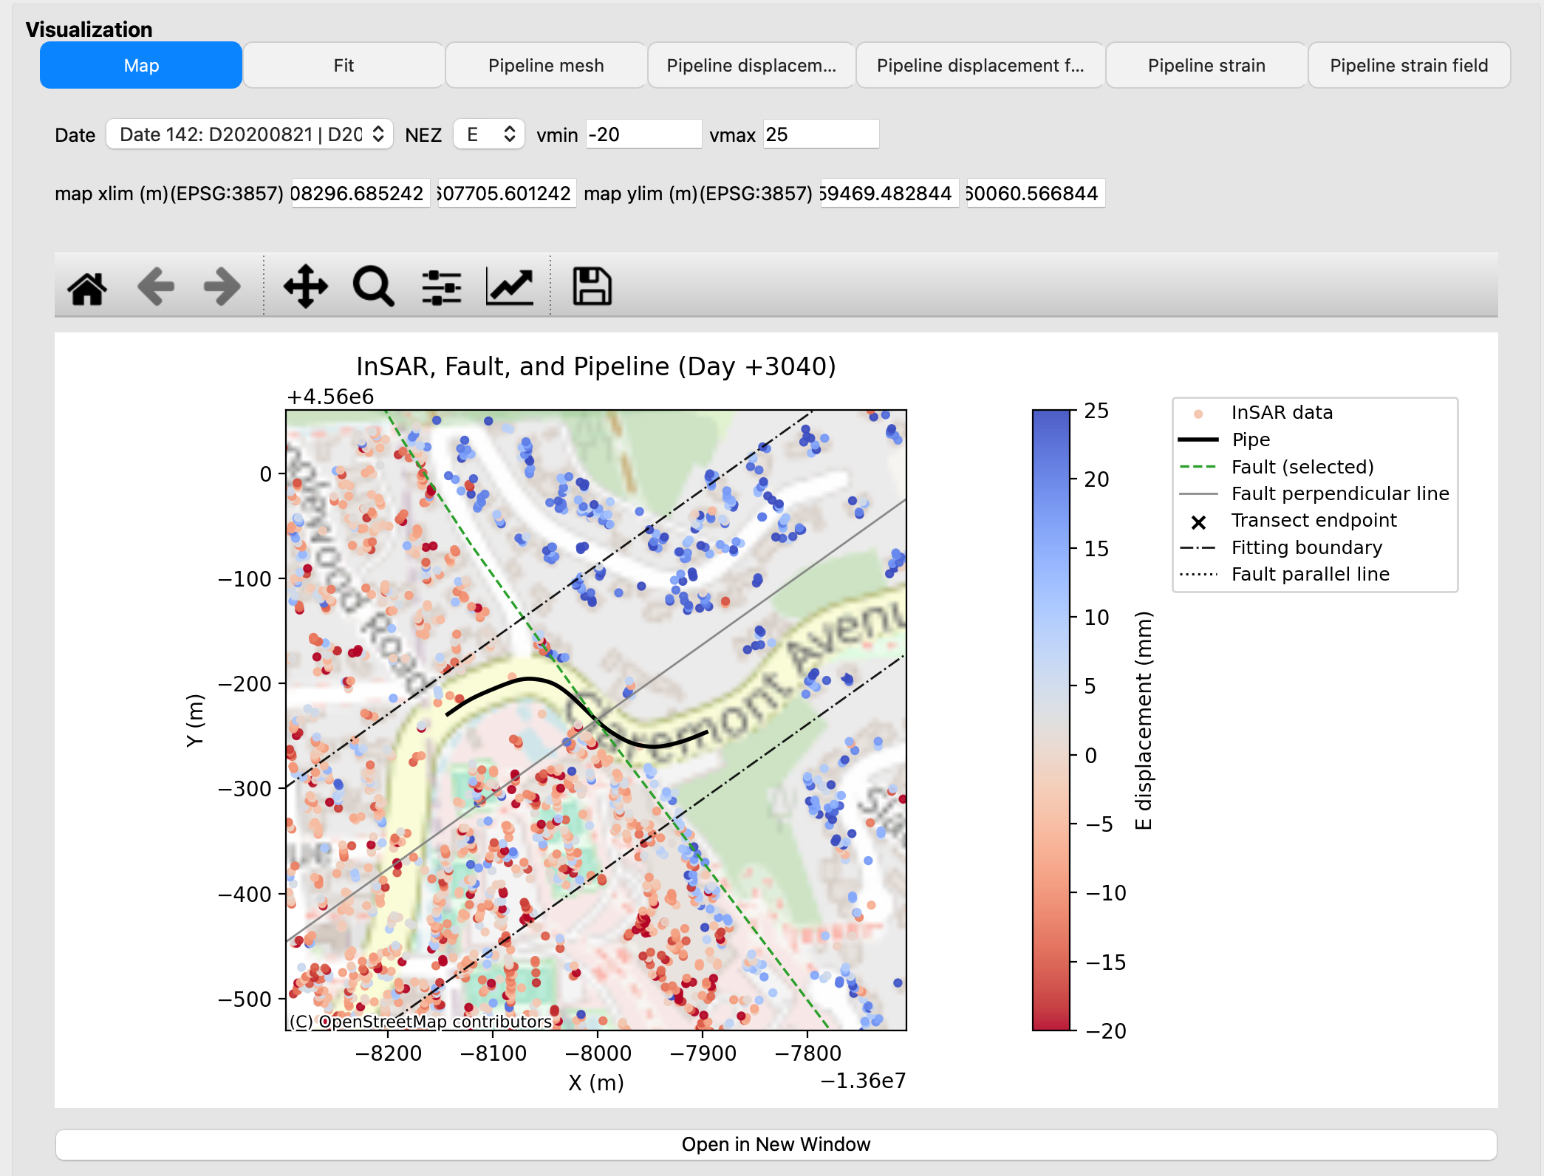

In the right panel, users can view maps, fitting results, pipeline mesh, displacement results, and strain results. In the visualization area, users can switch InSAR observation date, orientation, and coordinate representation etc., while reviewing outputs.

The log panel reports progress, fit sample counts, model diagnostics, and warning messages.
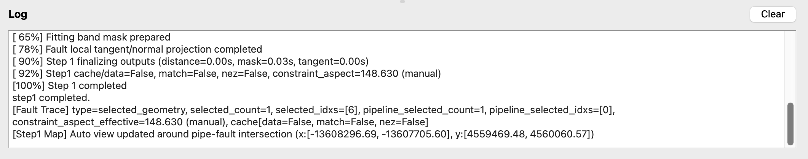

4.2 Date and Coordinate-System Selectors
A date selector allows epoch-wise inspection of results when multiple matched date pairs are available. The displayed dates correspond to a matched acquisition pair, consisting of one observation from the ascending InSAR dataset and one from the descending InSAR dataset. The pair is used for displacement decomposition.

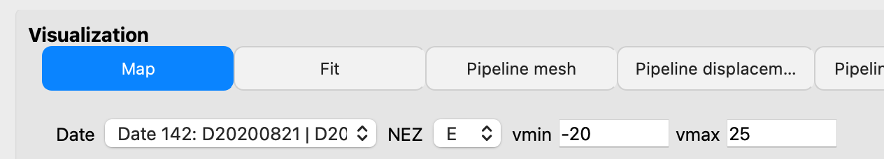
A coordinate-system selector controls how displacement/strain curves are presented:
- Fault-parallel/perpendicular
- N&E (North and East)

4.3 Fit Tab Interaction Elements
The Fit tab includes controls to:
- switch displayed fit data mode,
- inspect scatter and fitted curves,
- export fit scatter data,
- apply/reset fit overrides (a, b, c, d),
- select override fit dir
- launch advanced Sigmoid b Enhancement.

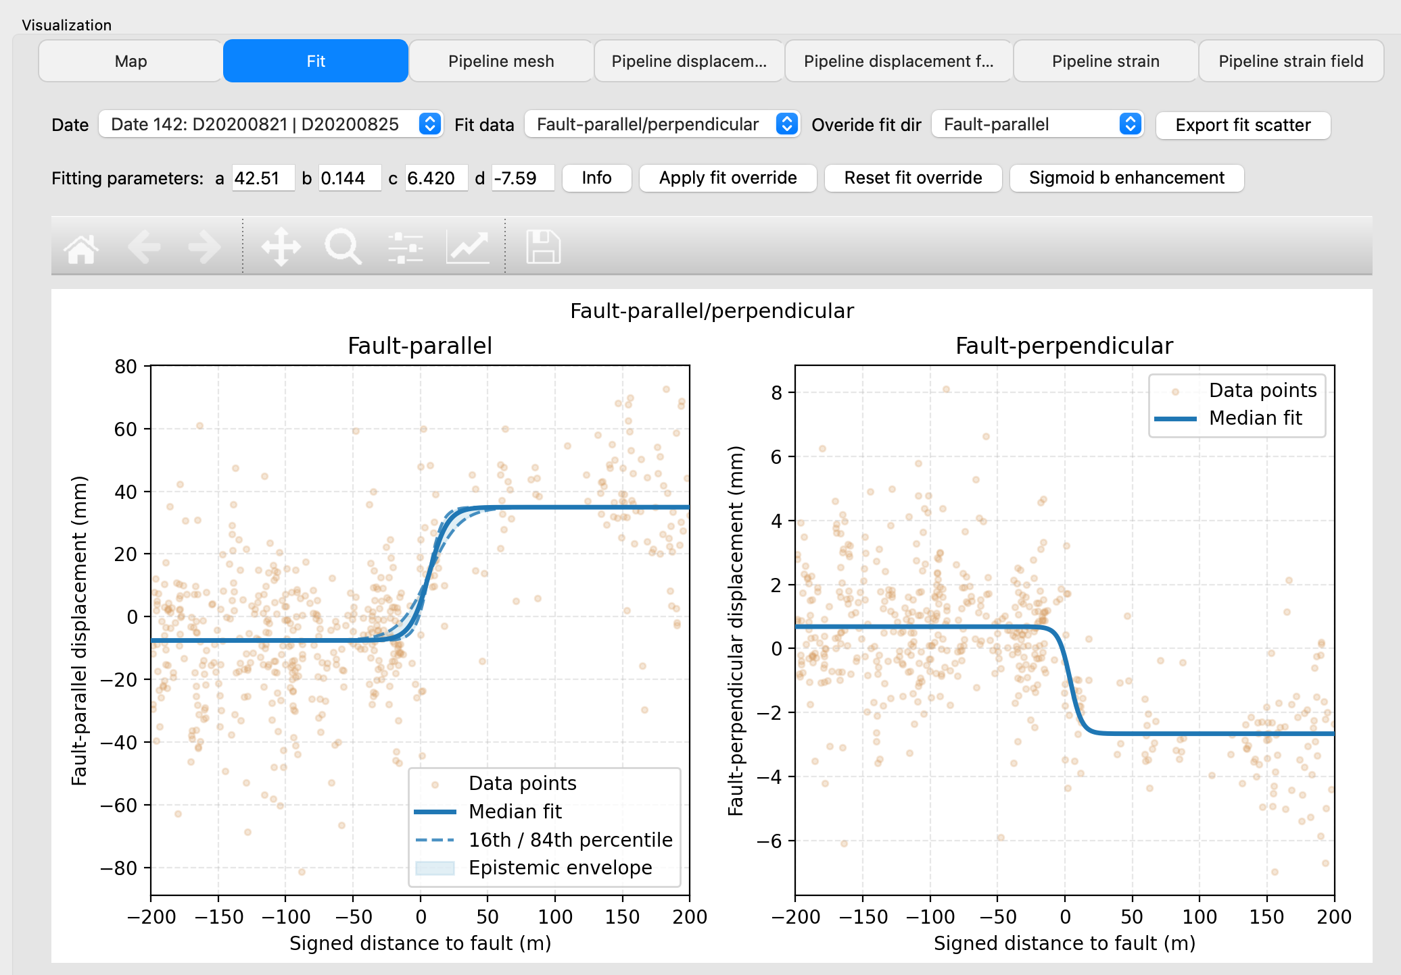

This Fit tab is the main checkpoint for validating whether downstream displacement/strain outputs are likely to be reliable.

5. Input Data

5.1 Required Input Files
The software requires four primary geospatial inputs and one output location before any analysis can run. Users must provide an ascending InSAR shapefile (*.shp), a descending InSAR shapefile (*.shp), a fault line shapefile (*.shp), and a pipeline axis geometry file (*.shp or *.npy). In addition, an output directory must be selected to store runtime products, exported figures, and analysis results.

5.2 InSAR Data Requirements
Before running the full workflow, users are encouraged to verify that both datasets refer to the same coordinate frame and represent physically comparable displacement measurements.

6. Core Analysis Workflow

6.1 Workflow Overview
The software organizes analysis into four sequential steps. Each step consumes outputs from earlier steps and adds new model products for visualization and export. While the interface allows repeated runs of individual steps, reliable interpretation depends on maintaining dependency order and rerunning upstream steps whenever key inputs or settings change.

6.2 Step 1: Solve Ground Motion
Step 1 loads inputs, performs date and spatial matching between ascending and descending InSAR observations, computes 3D displacement components, and prepares geometric context for later fitting

After clicking Run Step 1, two selection windows open, allowing users to interactively select the desired pipeline and fault segments from the networks. The selected pipeline and fault segments are highlighted in red, as shown in the following figures.

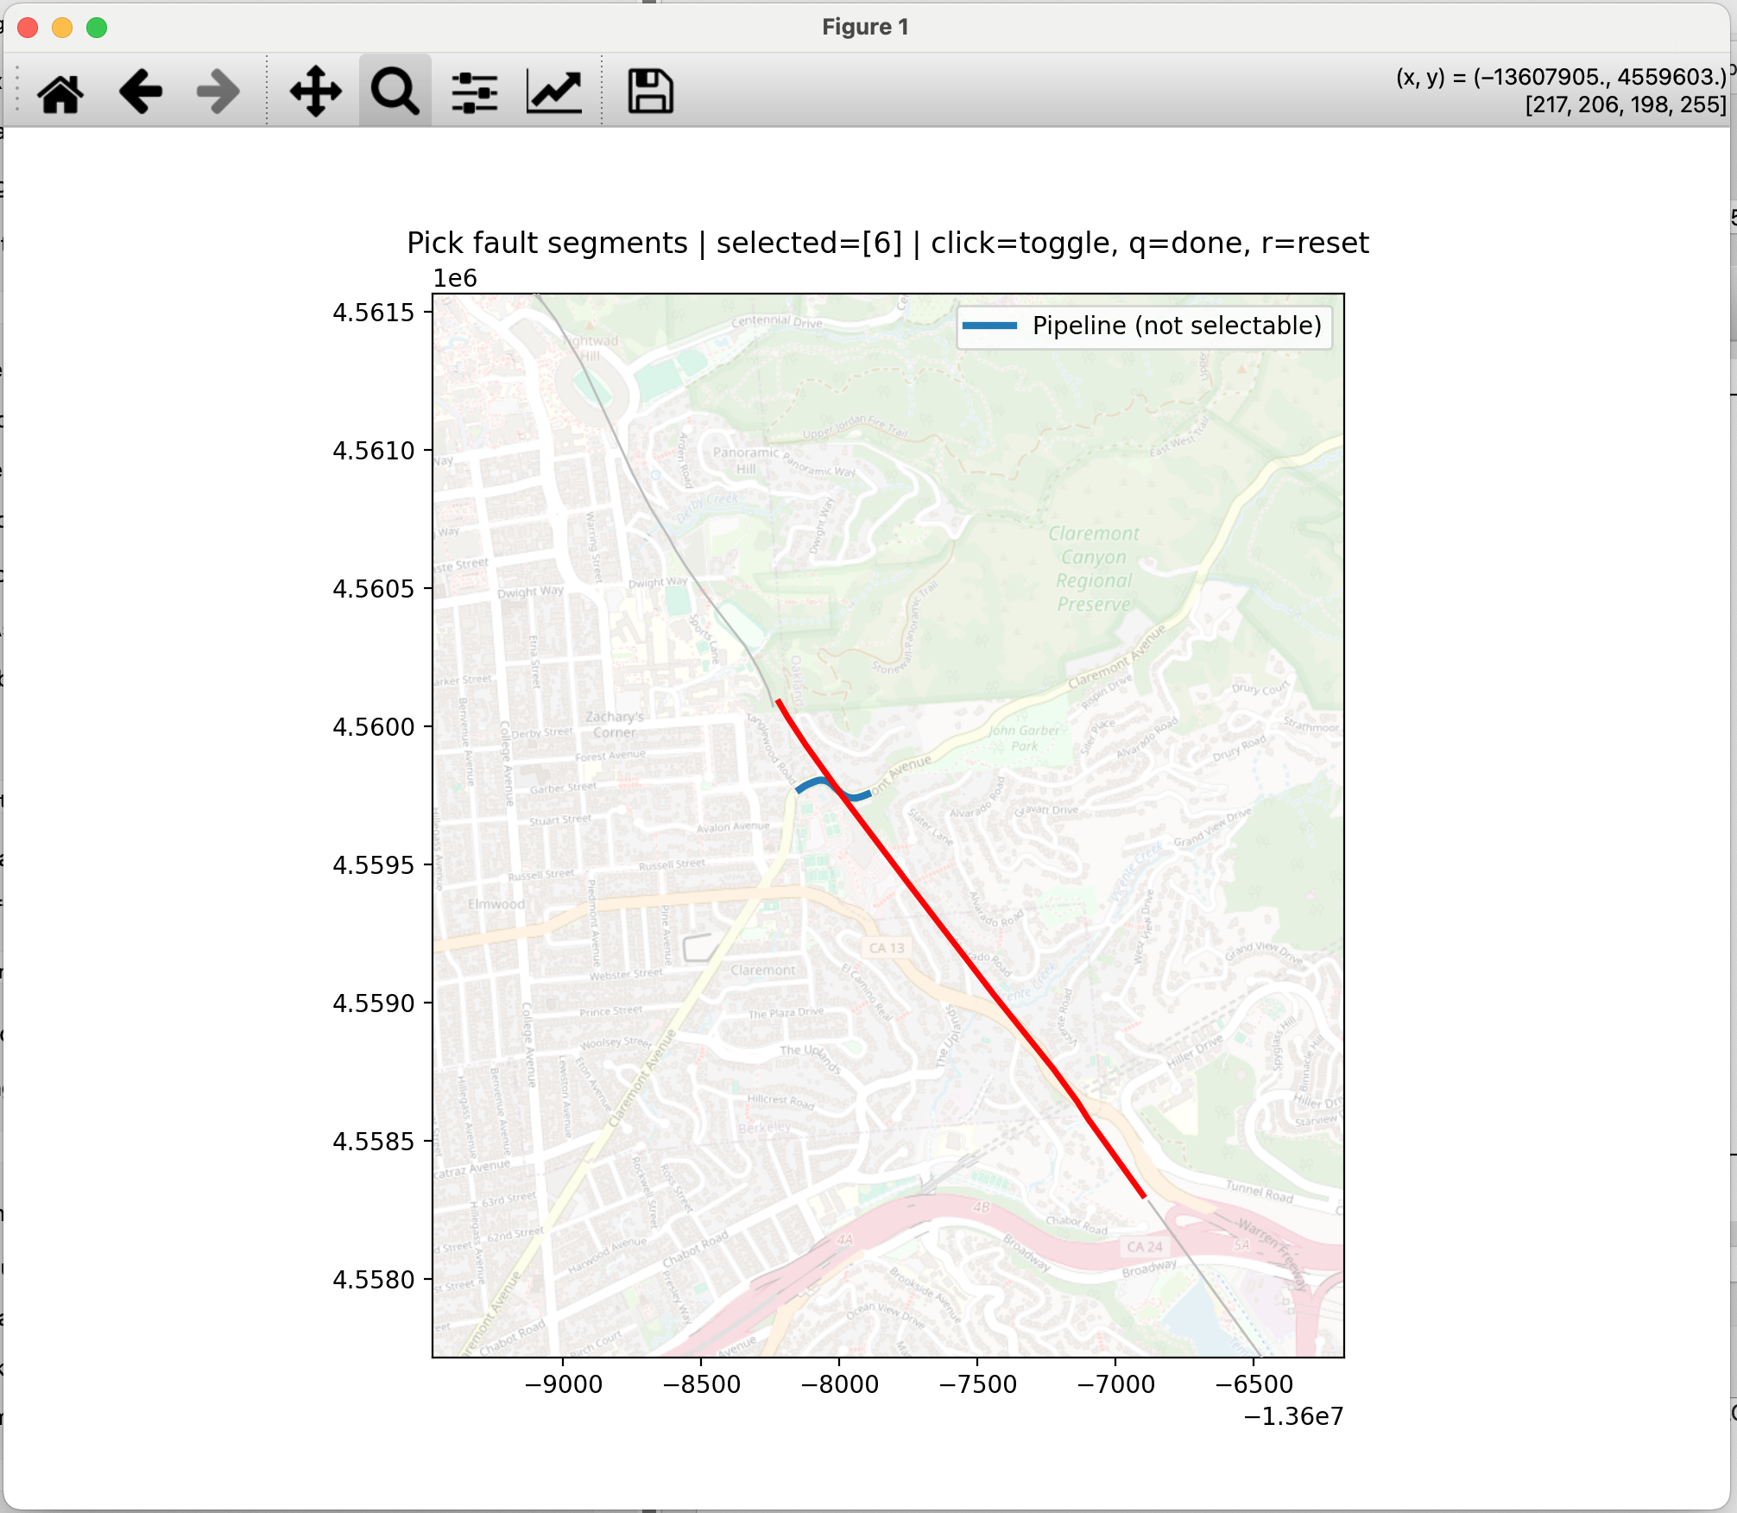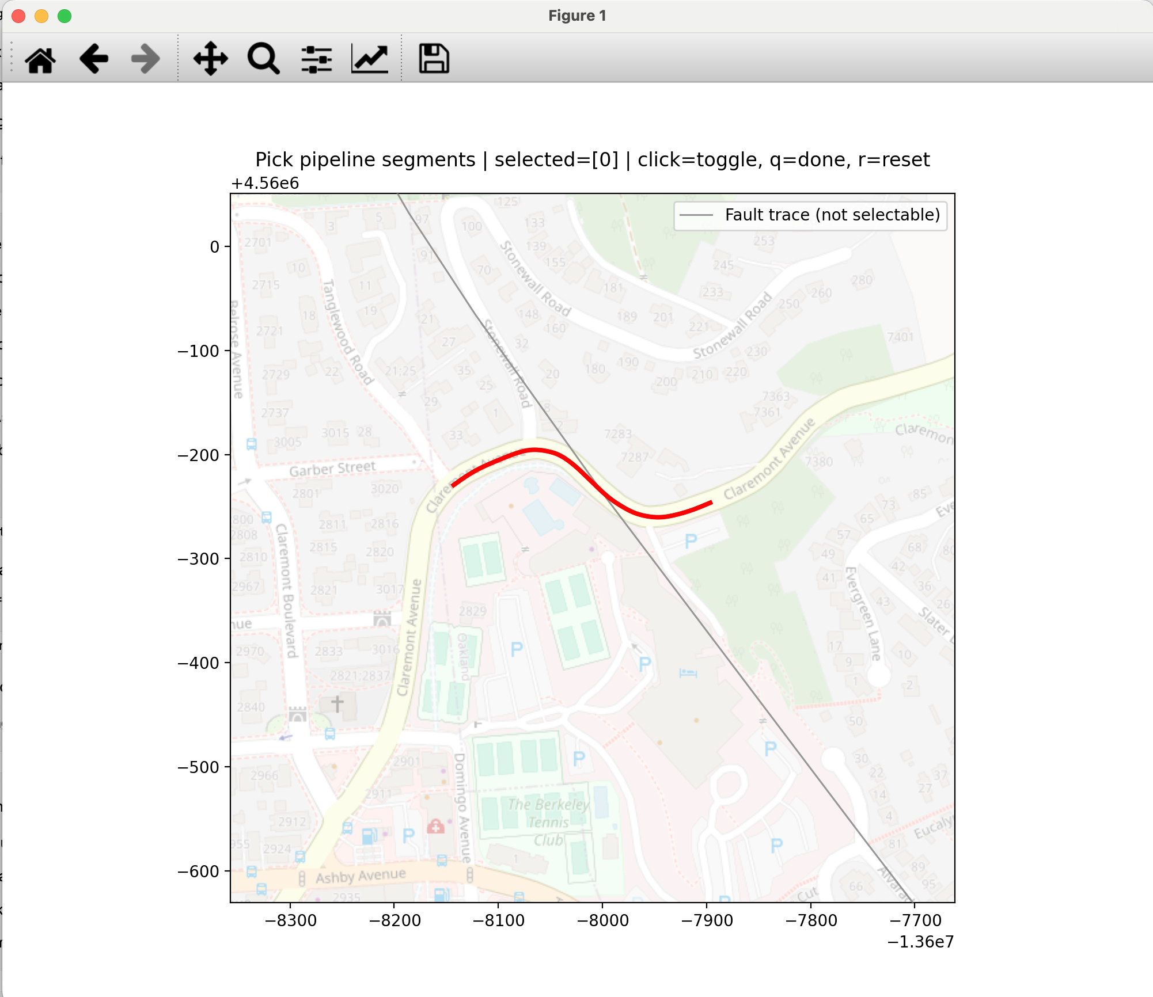

The outputs of Step 1 define the results available to Step 2, as shown in the following figure. If Step 1 produces too few matched points, subsequent shape-function fitting will be unstable regardless of downstream parameter tuning. For this reason, users can change InSAR data matching parameters, e.g., data match max days and spatial matching max distance, to increase the data amount.
Description of each parameter:
- Date: Selects which matched ascending/descending date pair is currently displayed in the map view.
- NEZ: Chooses which displacement component (North, East, or Vertical/Z) is visualized for the selected date.
- vmin: Sets the lower bound of the map color scale (leave auto to use automatic scaling).
- vmax: Sets the upper bound of the map color scale (leave auto to use automatic scaling).
- map xlim min (m): Defines the left x-axis boundary of the map viewport in the processing CRS units (meters).
- map xlim max (m): Defines the right x-axis boundary of the map viewport in the processing CRS units (meters).
- map ylim min (m): Defines the lower y-axis boundary of the map viewport in the processing CRS units (meters).
- map ylim max (m): Defines the upper y-axis boundary of the map viewport in the processing CRS units (meters).

6.3 Step 2: Fit Shape Function
Step 2 fits displacement- distance relationships over the selected fitting subset data. In the current workflow, sigmoid fitting uses four parameters (a, b, c, and d) and supports uncertainty handling through epistemic b variants (b16, b50, b84). These variants are estimated directly from the variances of parameters in the fitting process.
Step 2 fits the displacement–distance relationship using the selected subset of data. A four-parameter sigmoid function, characterized by a, b, c, and d, is fitted using SciPy’s curve_fit routine. The covariance matrix returned by curve_fit is used to estimate the parameter uncertainties. Epistemic uncertainty in parameter b is represented by b16, b50, and b84, which are approximated as b-sigma_b, b, and b+sigma_b, respectively, assuming an approximately normal parameter distribution.
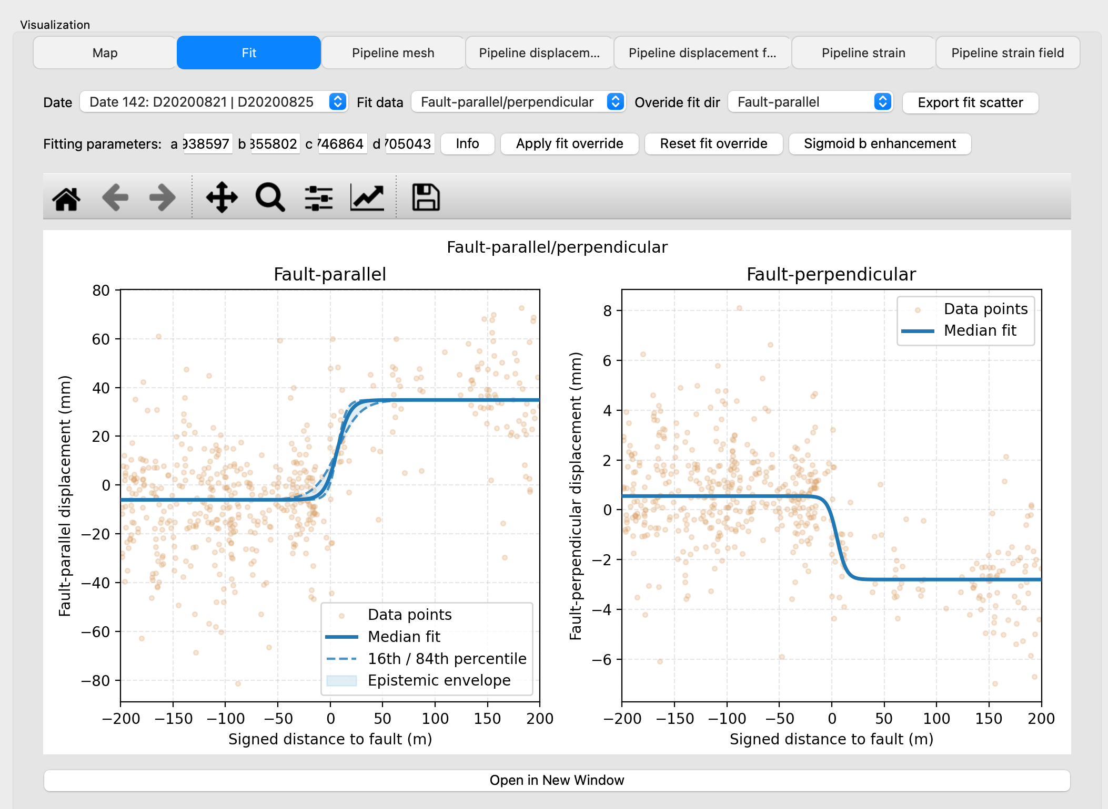

Description of each parameter:
- Date: Selects the matched InSAR date pair used for displaying and editing the fit results.
- Fit data: Chooses the fitting coordinate frame (Fault-parallel/perpendicular or N&E) for visualization and fitting context.
- Overide fit dir: Selects which fault-direction fit component is being viewed or manually overridden (Fault-parallel or Fault-perpendicular).
- Fitting parameters (a): Amplitude parameter of the selected sigmoid fit curve.
- Fitting parameters (b): Steepness parameter controlling how sharp the sigmoid transition is.
- Fitting parameters (c): Horizontal shift parameter defining the sigmoid transition center location.
- Fitting parameters (d): Vertical offset parameter setting the baseline level of the sigmoid curve.
- Info: Opens the following explanatory image illustrating the sigmoid fitting concept and parameter meaning.
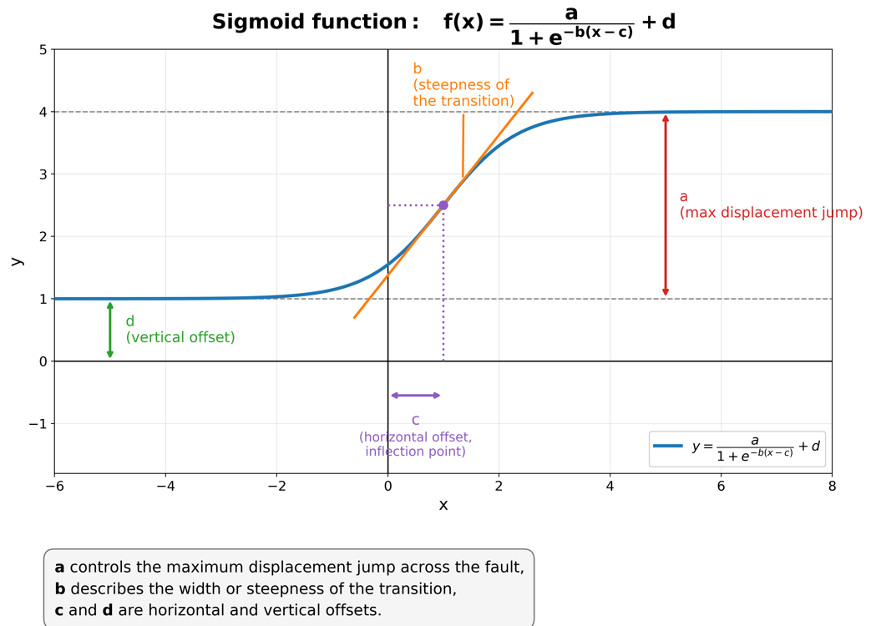
- Apply fit override: Applies the currently entered a/b/c/d values as a manual override for the selected date and fit direction.
- Reset fit override: Clears the manual override for the selected date and direction and restores the default fitted parameters.
- Sigmoid b enhancement: Launches the advanced sigmoid b analysis workflow to evaluate and recommend robust sigmoid b values from sliding-window analyses.
- Export fit scatter: Exports the fit scatter data for the current date/direction for external review or post-processing.

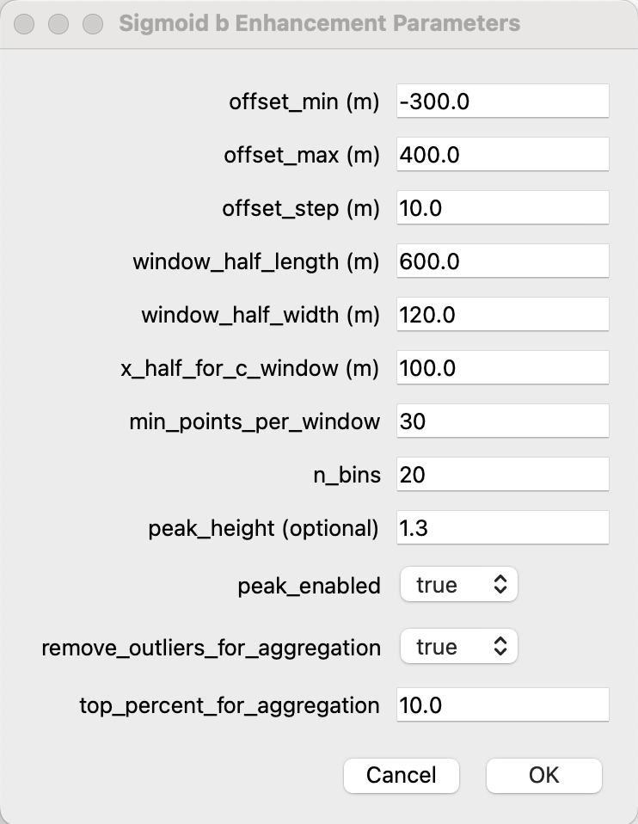
Descriptions of Sigmoid b Enhancement Parameters:
- offset_min (m): Minimum along-fault offset where sliding-window evaluations start.
- offset_max (m): Maximum along-fault offset where sliding-window evaluations stop.
- offset_step (m): Spacing between consecutive sliding-window center offsets.
- window_half_length (m): Half-length of each fitting window measured along the fault trace.
- window_half_width (m): Half-width of each fitting window measured perpendicular to the fault trace.
- x_half_for_c_window (m): Half-range around the local center used to cover the width of the transition zone.
- min_points_per_window: Minimum number of valid InSAR points required for a window to be accepted for fitting.
- n_bins: Number of bins used to discretize/profile data for window-level fitting diagnostics.
- peak_height (optional): Optional minimum peak height threshold used to filter weak peaks before outlier tagging.

Step 2 is the most important quality-control stage. Users should inspect both scatter and fitted curves in the Fit tab and check that model behavior is physically plausible.

6.4 Step 3: Estimate Pipeline Displacement
Step 3 applies fitted shape functions to the pipeline mesh and estimates displacement response along the axis. Depending on settings, the software can compute both soil and pipe displacement and include uncertainty envelopes for the function of fault-parallel direction.
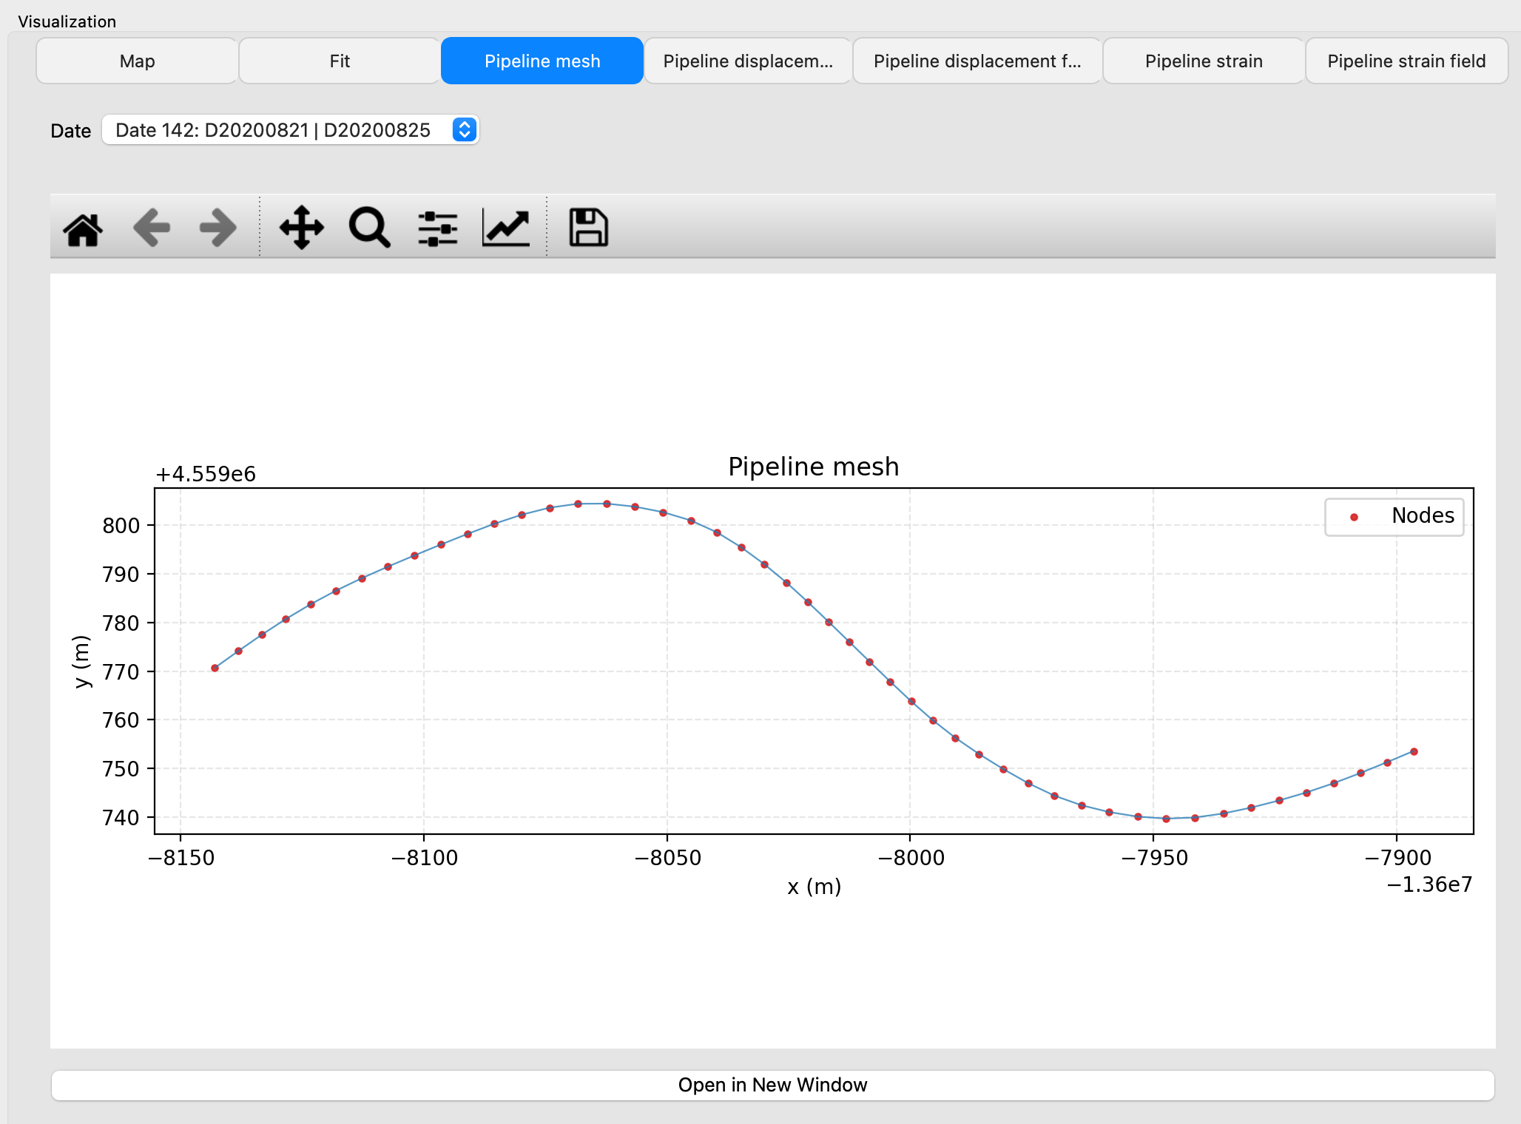

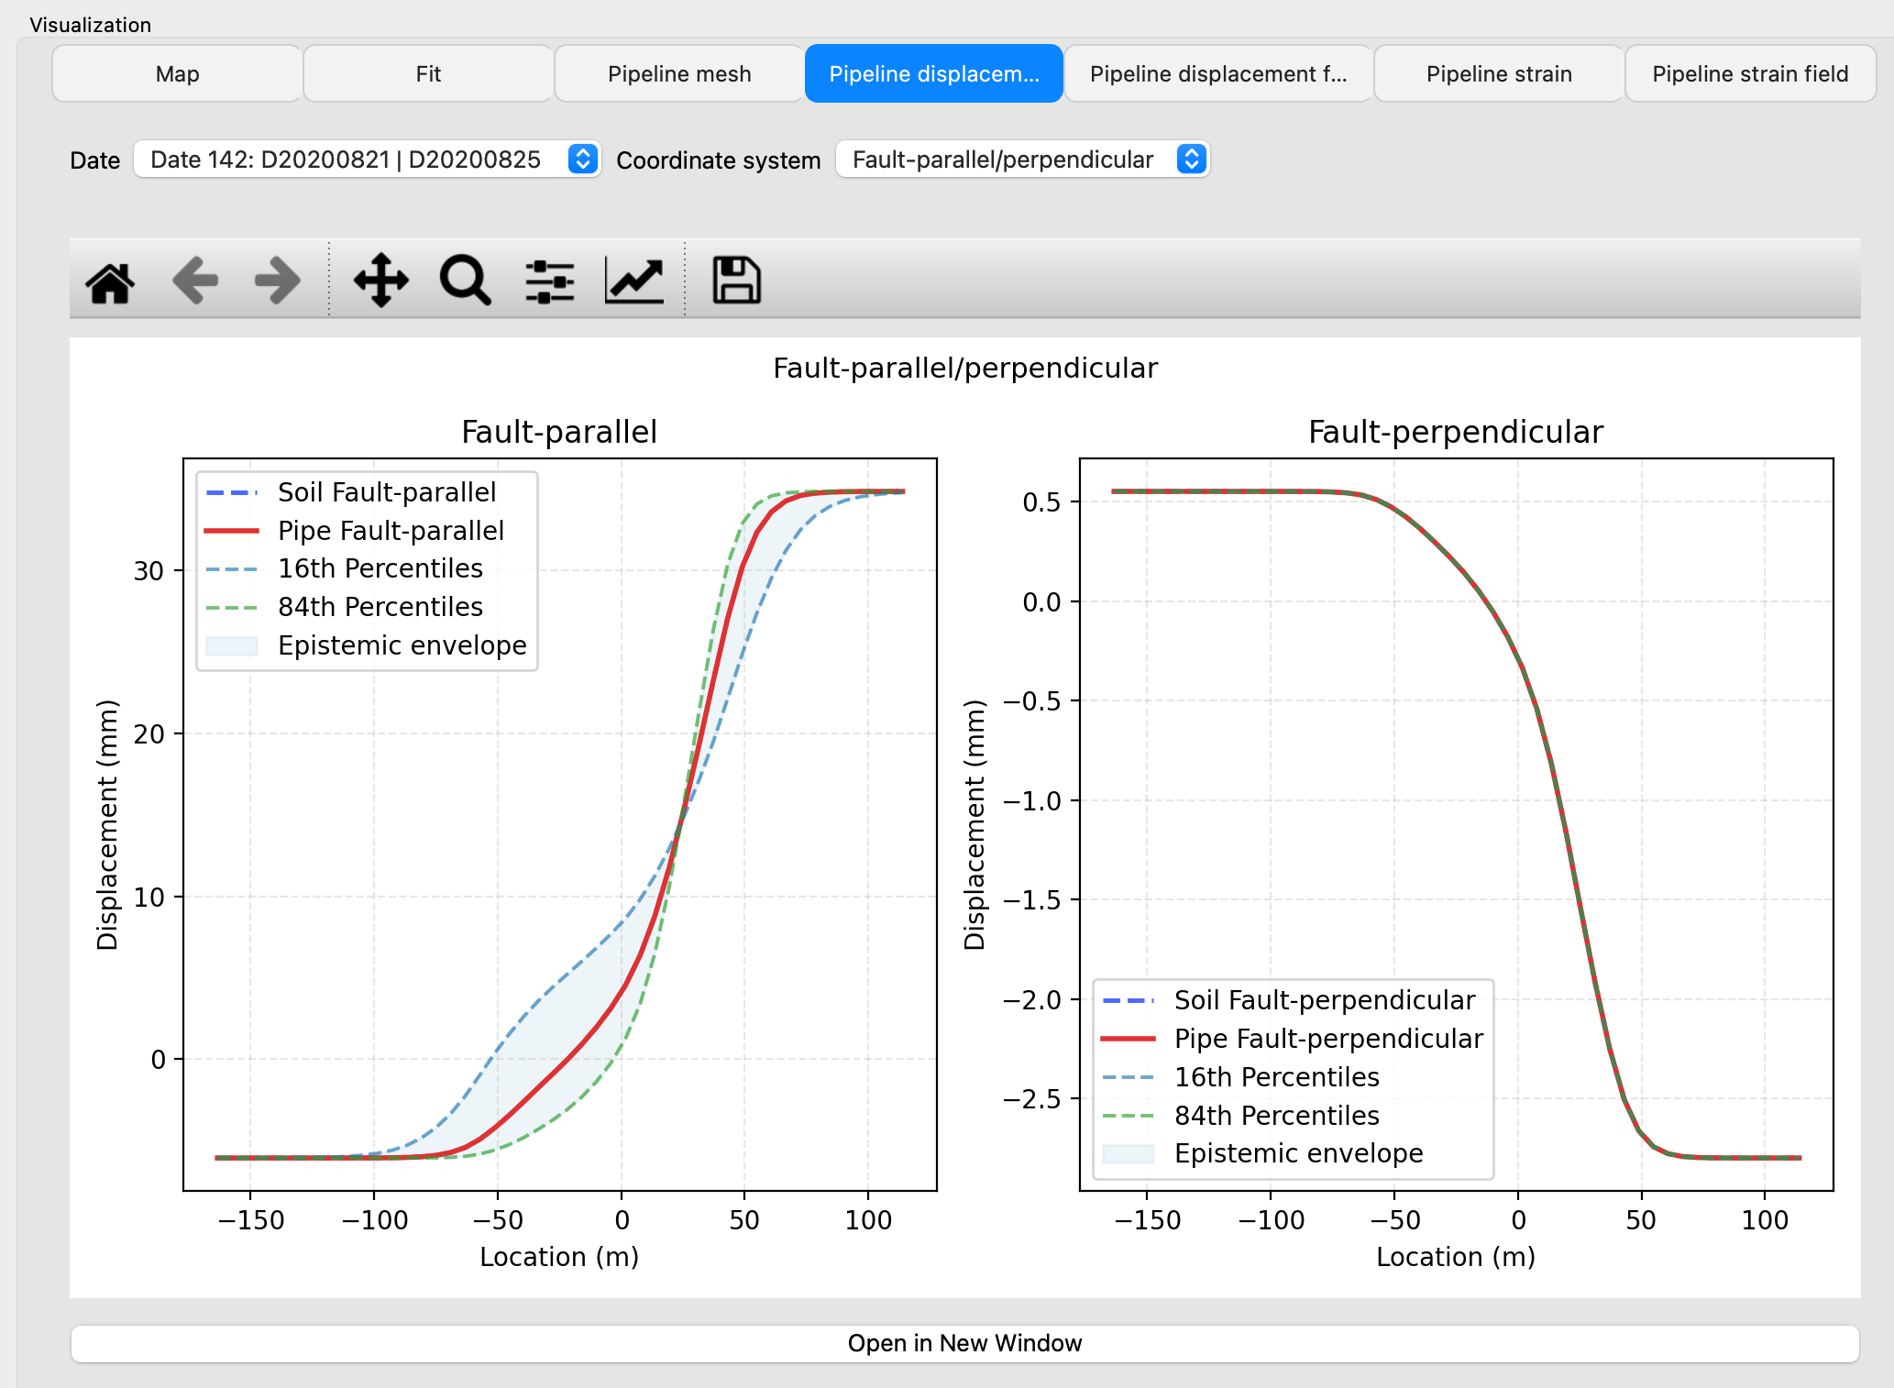

Description of each parameter:
- Date: Selects the matched ascending/descending date pair used to display the pipeline displacement profiles for that epoch.
- Coordinate system: Chooses whether displacement is shown in Fault-parallel/perpendicular components or in geographic N&E components.

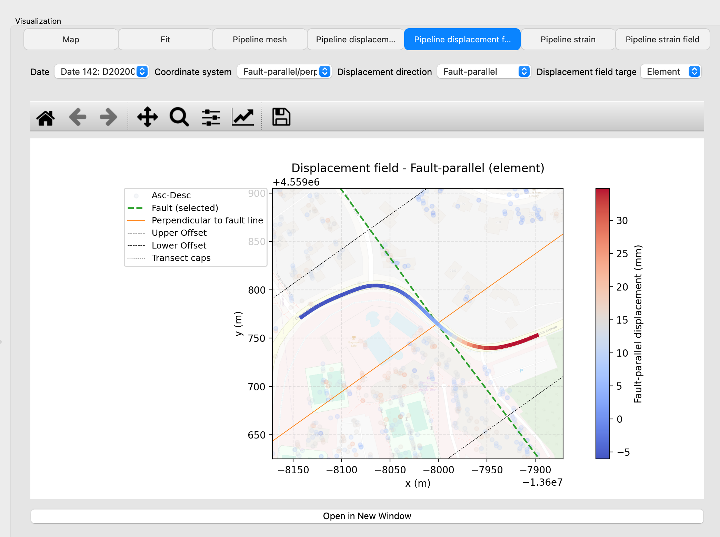

Description of each parameter:
- Date: Selects the matched date pair used to display the displacement-field result for that epoch.
- Coordinate system: Defines whether the field values are interpreted in Fault-parallel/perpendicular components or in N&E components.
- Displacement direction: Selects which displacement component is mapped in the field view (e.g., fault-parallel or fault-perpendicular, depending on coordinate system).
- Displacement field target: Chooses whether displacement is visualized on Node values or Element values of the pipeline mesh.

The displacement plots should be interpreted together with Step 2 quality. When the coordinate system selector is switched between N&E and Fault-parallel/perpendicular, users should expect meaningful changes in curve interpretation rather than identical shapes.

6.5 Step 4: Estimate Pipeline Strain
Step 4 computes strain measures from predicted displacement fields, including axial and bending-related responses. Results are shown in both profile and field form.

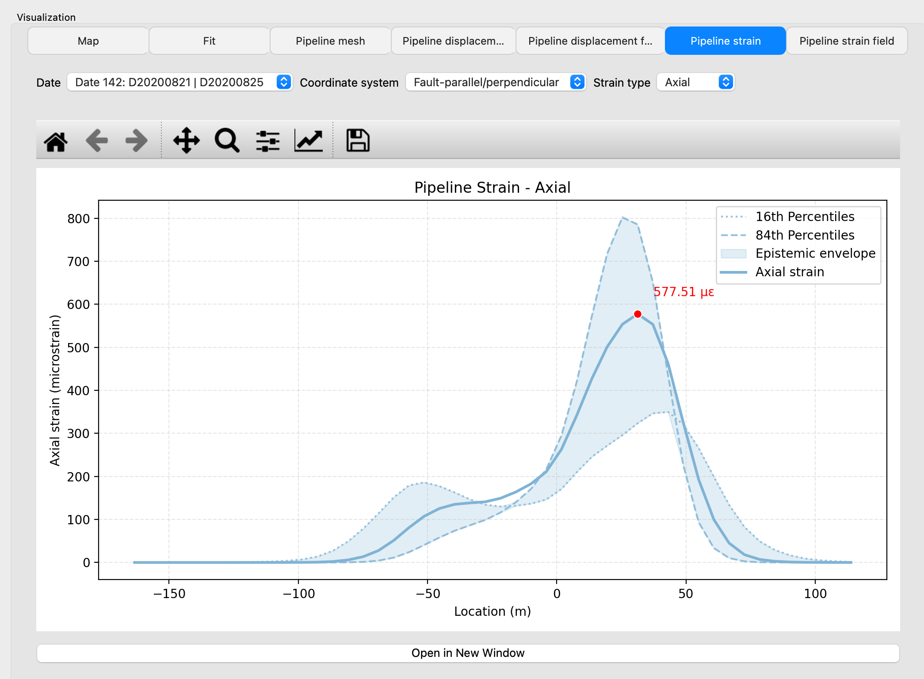
Description of each parameter:
- Date: Selects the matched date pair used to display the strain profile for that specific epoch.
- Coordinate system: Defines whether strain results are displayed under Fault-parallel/perpendicular or N&E displacement prediction context.
- Strain type: Chooses which strain component profile is plotted, such as Axial or Bending.

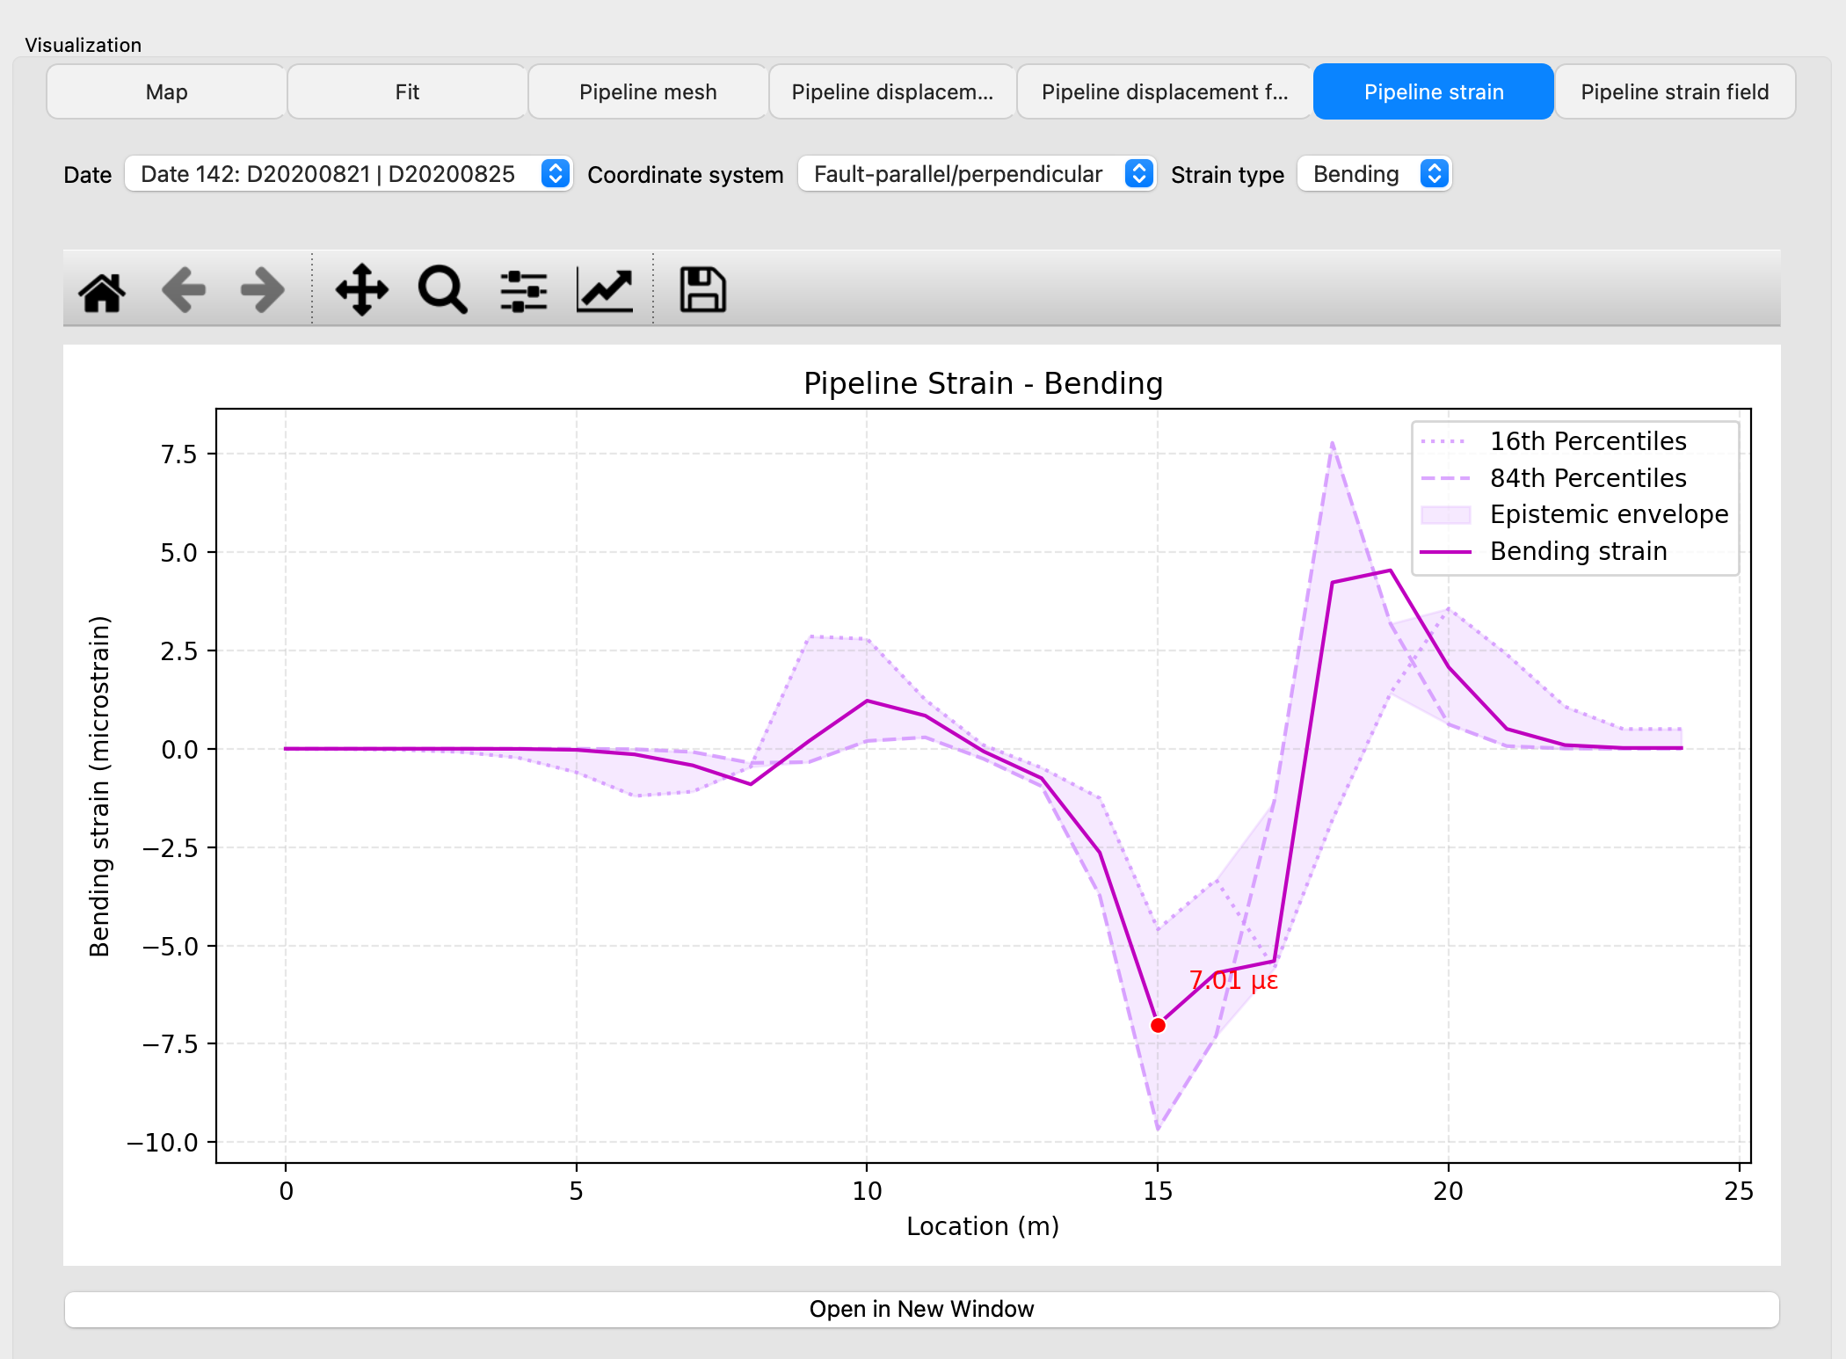

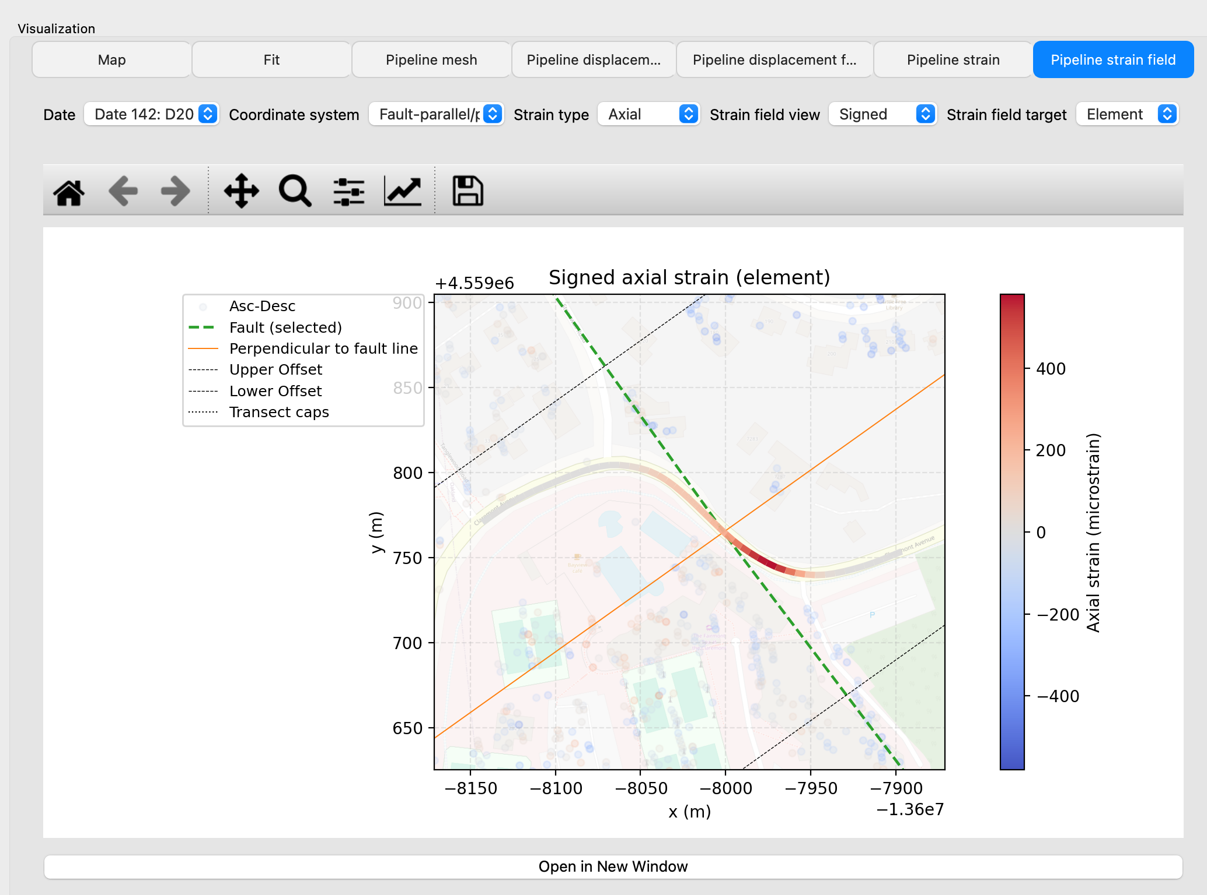

Description of each parameter:
- Date: Selects the matched date pair used to render the strain-field map for that epoch.
- Coordinate system: Chooses the displacement/strain reference frame used for field visualization (Fault-parallel/perpendicular or N&E).
- Strain type: Selects which strain component is visualized in the field (typically Axial or Bending).
- Strain field view: Controls whether the field shows signed strain values or absolute-magnitude strain values.
- Strain field target: Chooses whether strain is displayed at mesh Node locations or aggregated to Element values.

7. Fit Controls and Advanced Fitting Tools

7.1 Fit Controls in the Workflow
The Fit controls provide the main interface for tuning shape-function behavior after Step 2 has been executed. The default fitting results can be affected by the insufficient quality of InSAR data, this section enables users to review, adjust, and calibrate shape functions when data quality, sample distribution, or local geometry introduces undesired level of uncertainty.

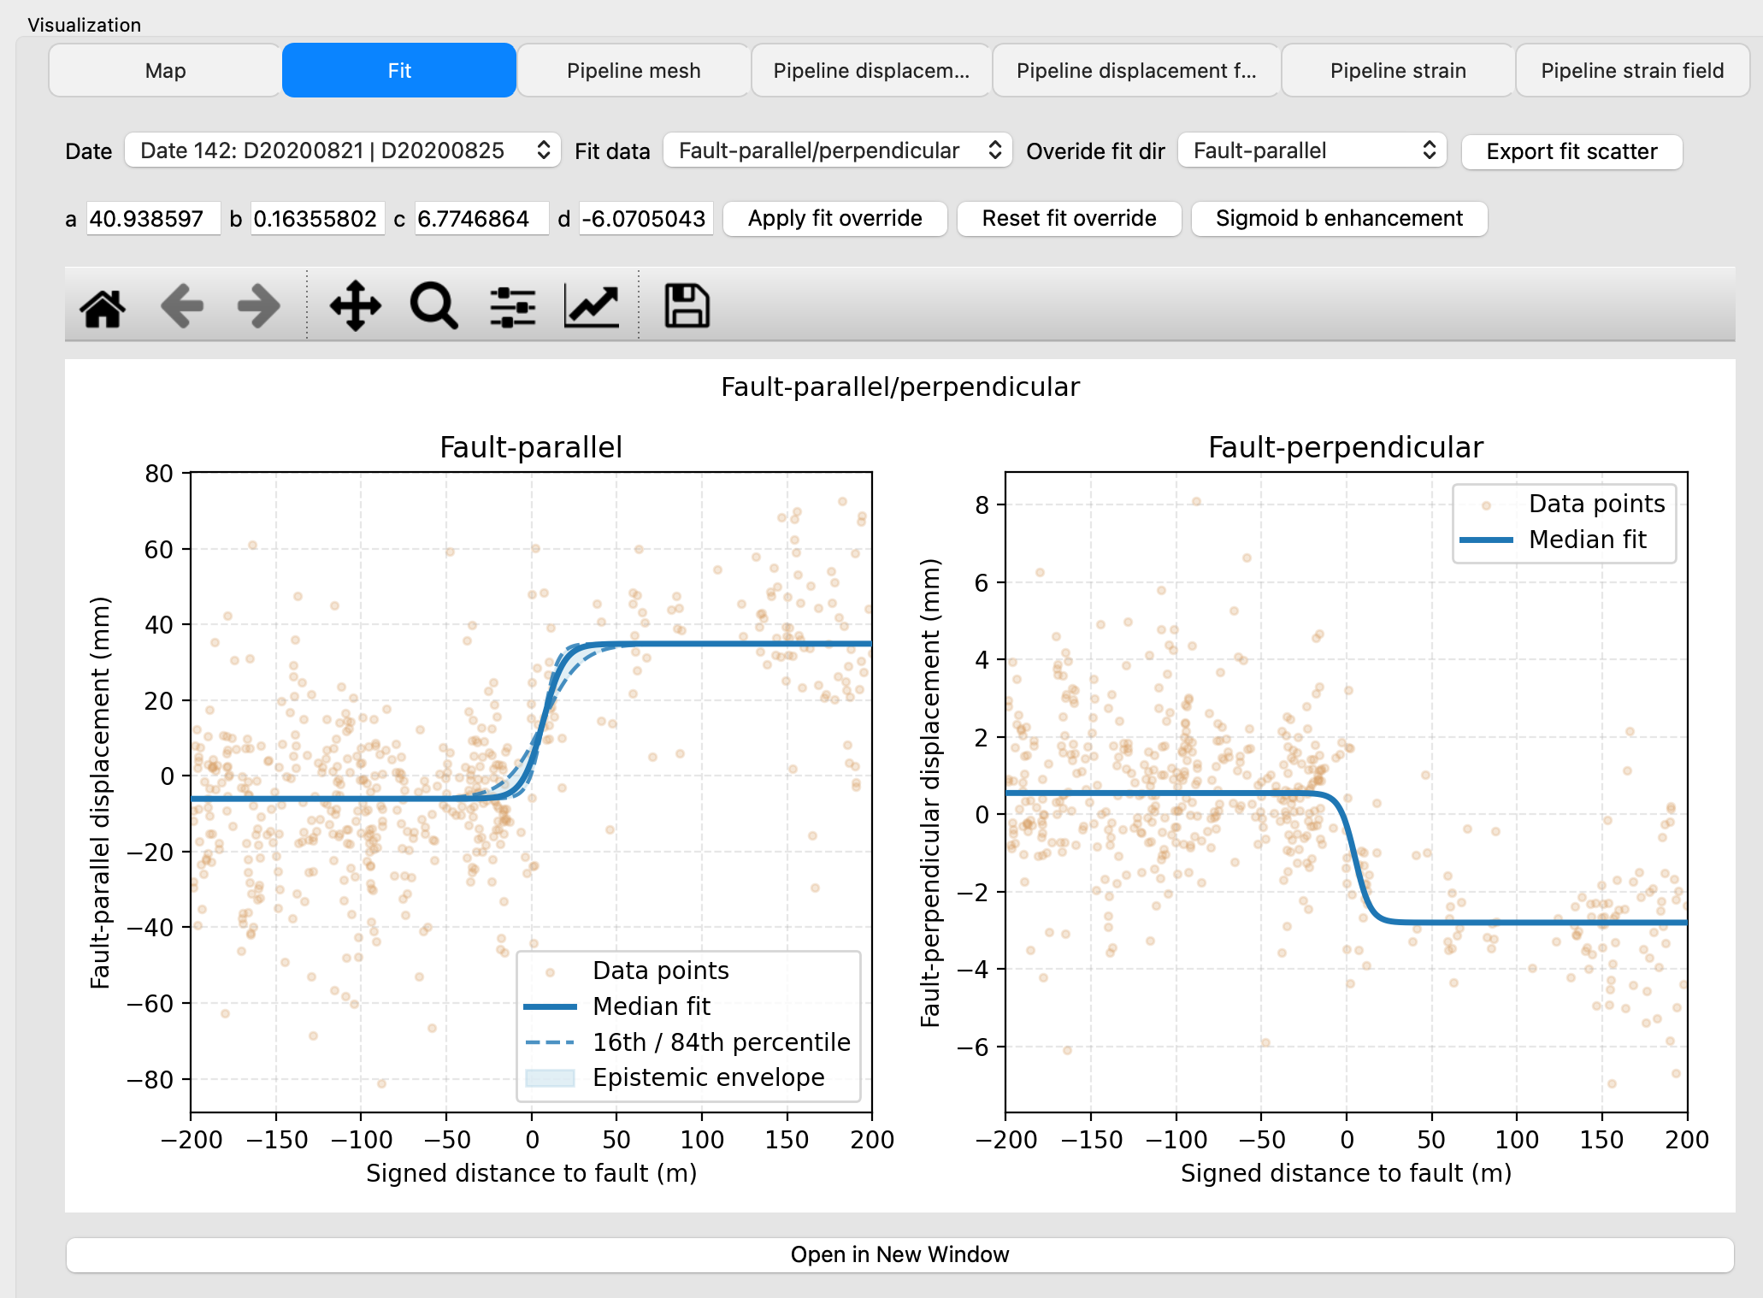

In practical use, these controls can be treated as an interface of calibration. Users are encouraged to run an initial Step 1-Step 2 sequence, inspect fit quality, and then apply targeted adjustments only where needed.

7.2 Fit Override (Manual Parameter Control)
The Fit panel supports direct override of sigmoid parameters so users can impose a controlled model when automatic fitting is unstable or physically implausible. The current sigmoid form uses four parameters: a, b, c, and d.
After entering values, selecting Apply fit override updates the active fit state for subsequent steps. Selecting Reset fit override returns to the fitted baseline generated by Step 2. Override behavior is intended to be explicit and user-driven; it is not automatically applied unless the user confirms it through the UI action. Override fit dir controls the direction of sigmoid shape function that the users intend to override.

7.3 Interpreting Sigmoid Parameters (a, b, c, d)
The parameter a controls the overall sigmoid amplitude, b controls transition width of sharpness, c controls transition center location along signed distance, and d controls offset. In this application, b is often the most sensitive parameter for downstream displacement and strain behavior, especially in fault-parallel interpretation and uncertainty propagation.
A very small b can result small peak displacement and strain estimates, while a large b can result a sharp edge and amplify local strain effects.

7.4 Fit Data Mode and Direction Context
The Fit tab allows users to inspect model behavior in both Fault-parallel/perpendicular and N&E coordinate systems. This switch changes plot labels.

7.5 Sigmoid b Enhancement: Purpose
The Sigmoid b Enhancement workflow is designed to address instability in single-location fitting by evaluating b across multiple sliding windows along the fault trace. Instead of relying on one local cross-section, the tool computes a series of candidate fits and summarizes them through diagnostics and aggregation logic.
This process is particularly useful when local data density is uneven or when one fitted b appears sensitive to subset selection.

The expected usage sequence is:
- Complete at least Step 2.
- Open Sigmoid b enhancement from the Fit area.
- Configure window motion and outlier-detection parameters.
- Run enhancement and review result tabs (overview, fit windows, coverage, metrics, aggregation).
- Decide whether to apply a selected b using available apply buttons or keep the current model.
The enhancement module provides recommendation support, but final adoption remains a user decision.
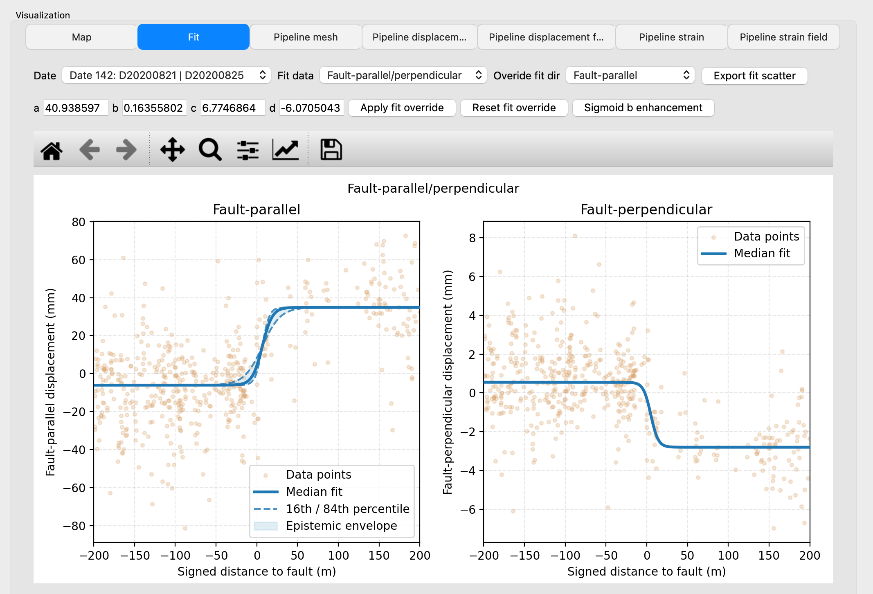

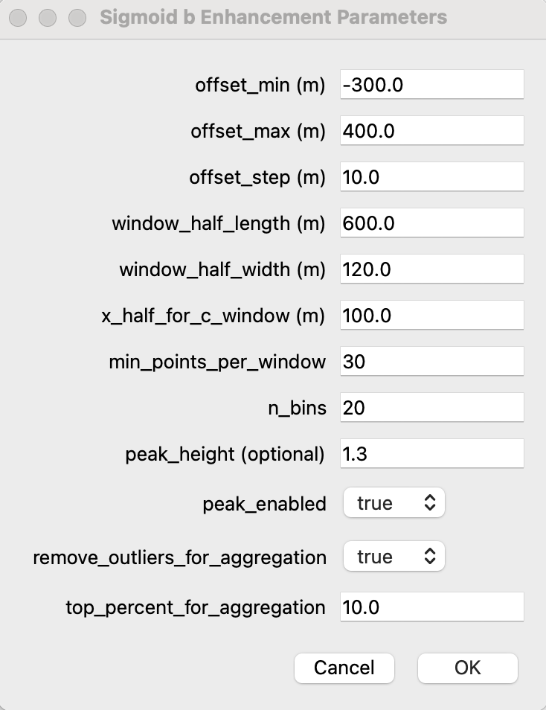
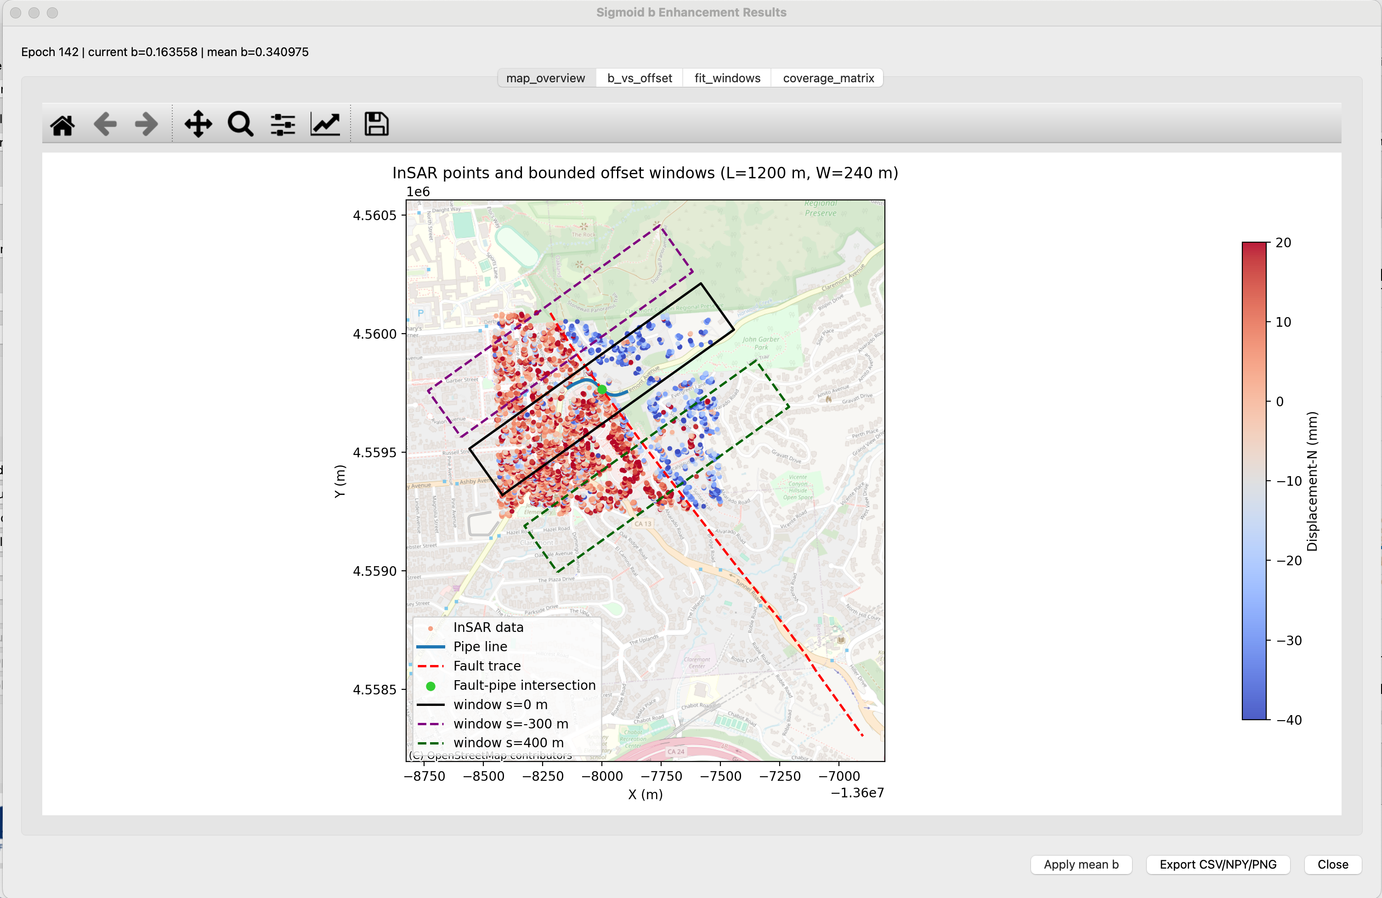

Description of each tab in the results:
- map_overview:
This tab provides a geographic check of the entire enhancement setup by overlaying InSAR displacement points, the pipeline axis, the selected/fitted fault trace, the fault-pipe intersection, and representative sliding windows at different offsets. The purpose is to let users verify that window placement, orientation, and data coverage align with the intended fault-crossing geometry and that the enhancement is analyzing the correct area.
- b_vs_offset:
This tab shows the correlation between fitted sigmoid b value and window offset along the fault trace. The motivation is that a single cross-section can produce unstable sigmoid b, while a sliding-window sweep reveals spatial variability and robustness trends. It can help users identify where sigmoid b is stable, where it is noisy, and whether detected outliers are consistent with the observed trend before aggregation.
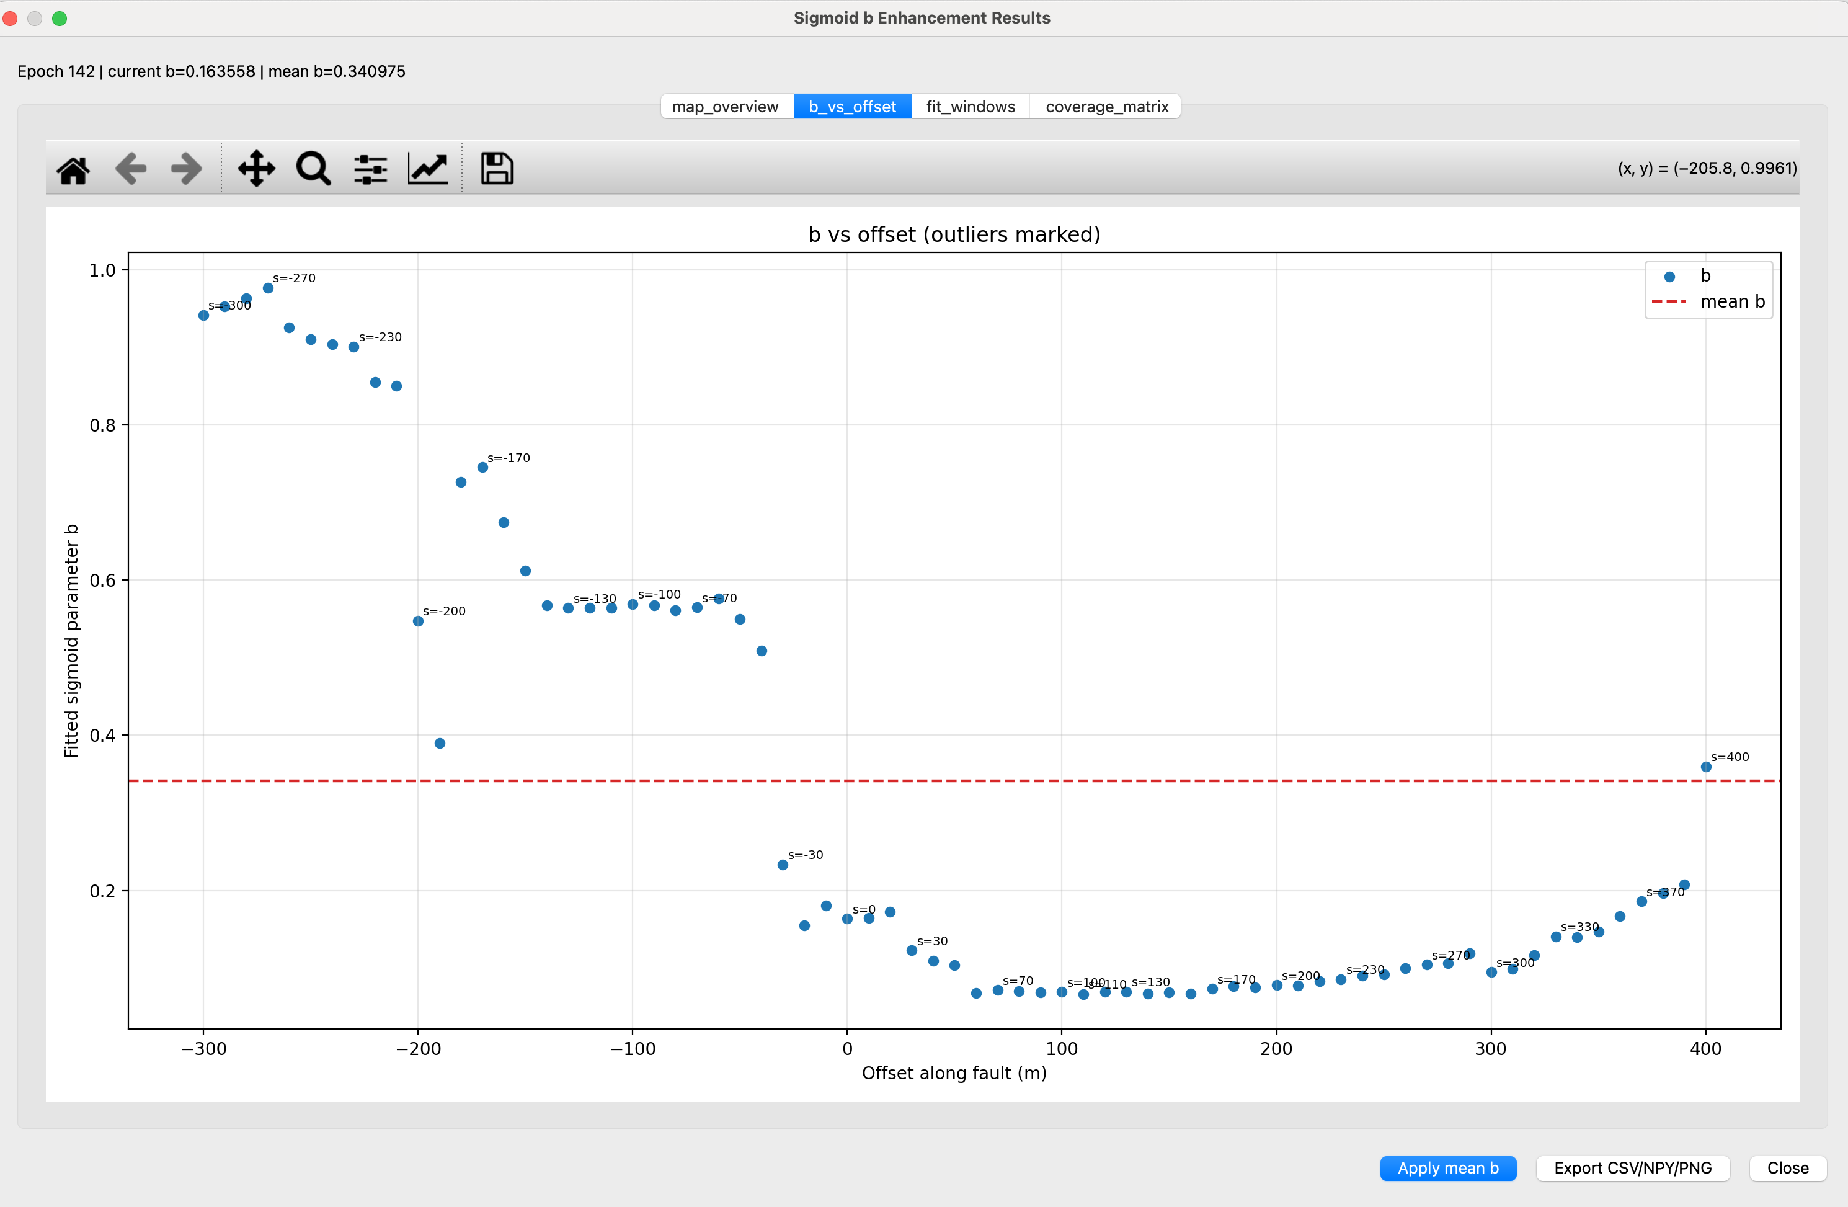
- fit_windows:
This tab displays window-level fitting behavior (e.g., raw points and fitted curve snapshots across sampled offsets) so users can inspect local fit quality directly.
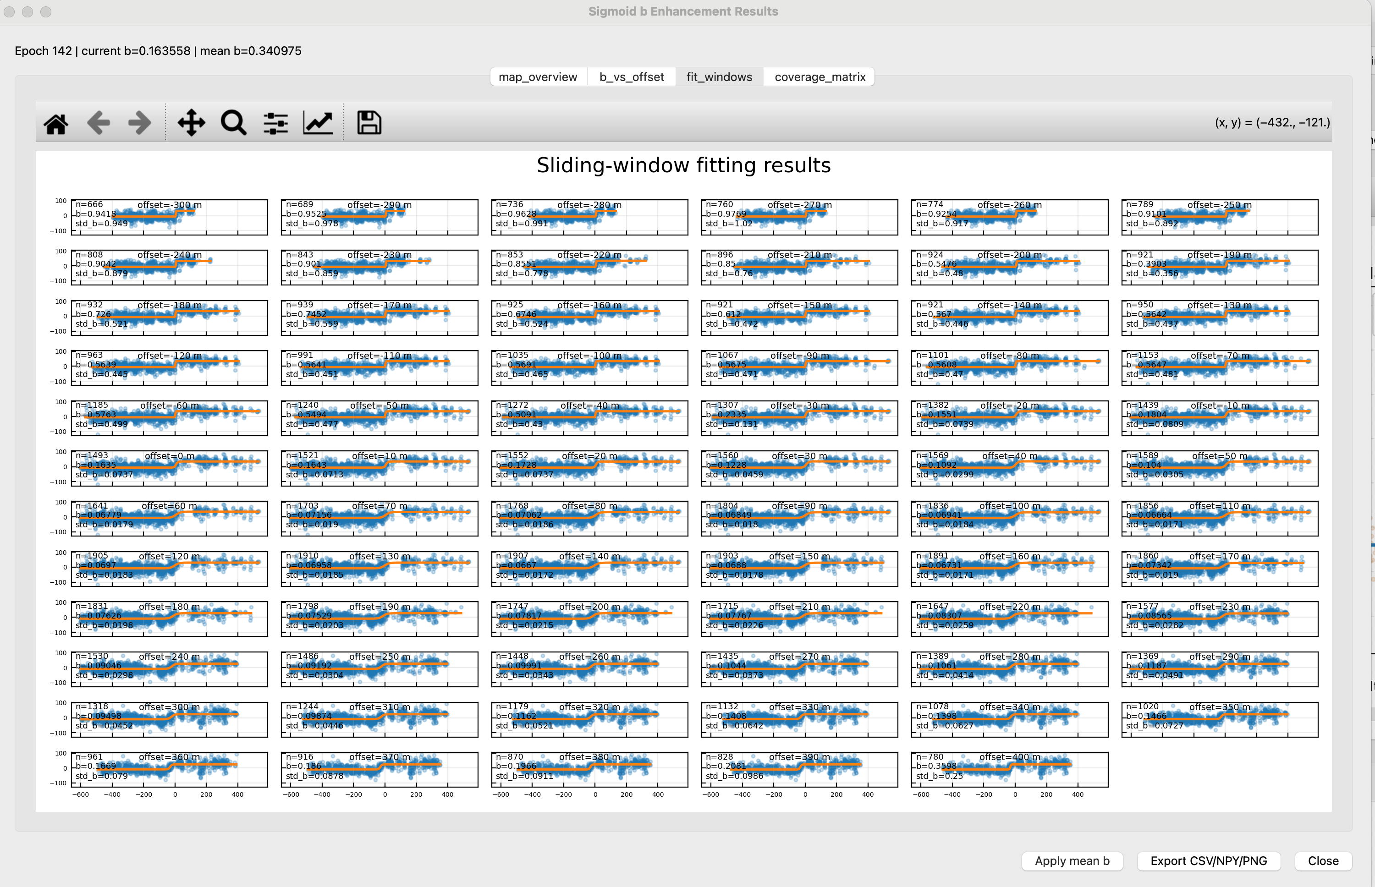

- coverage_matrix:
This tab summarizes data sufficiency and geometric support across windows (for example, point counts, spatial occupancy, or left/right fault-side coverage indicators). The motivation is to avoid over-weighting windows that are underconstrained or unevenly populated. It can expose where fit reliability is limited by sampling structure rather than true deformation behavior, supporting better interpretation and filtering decisions.

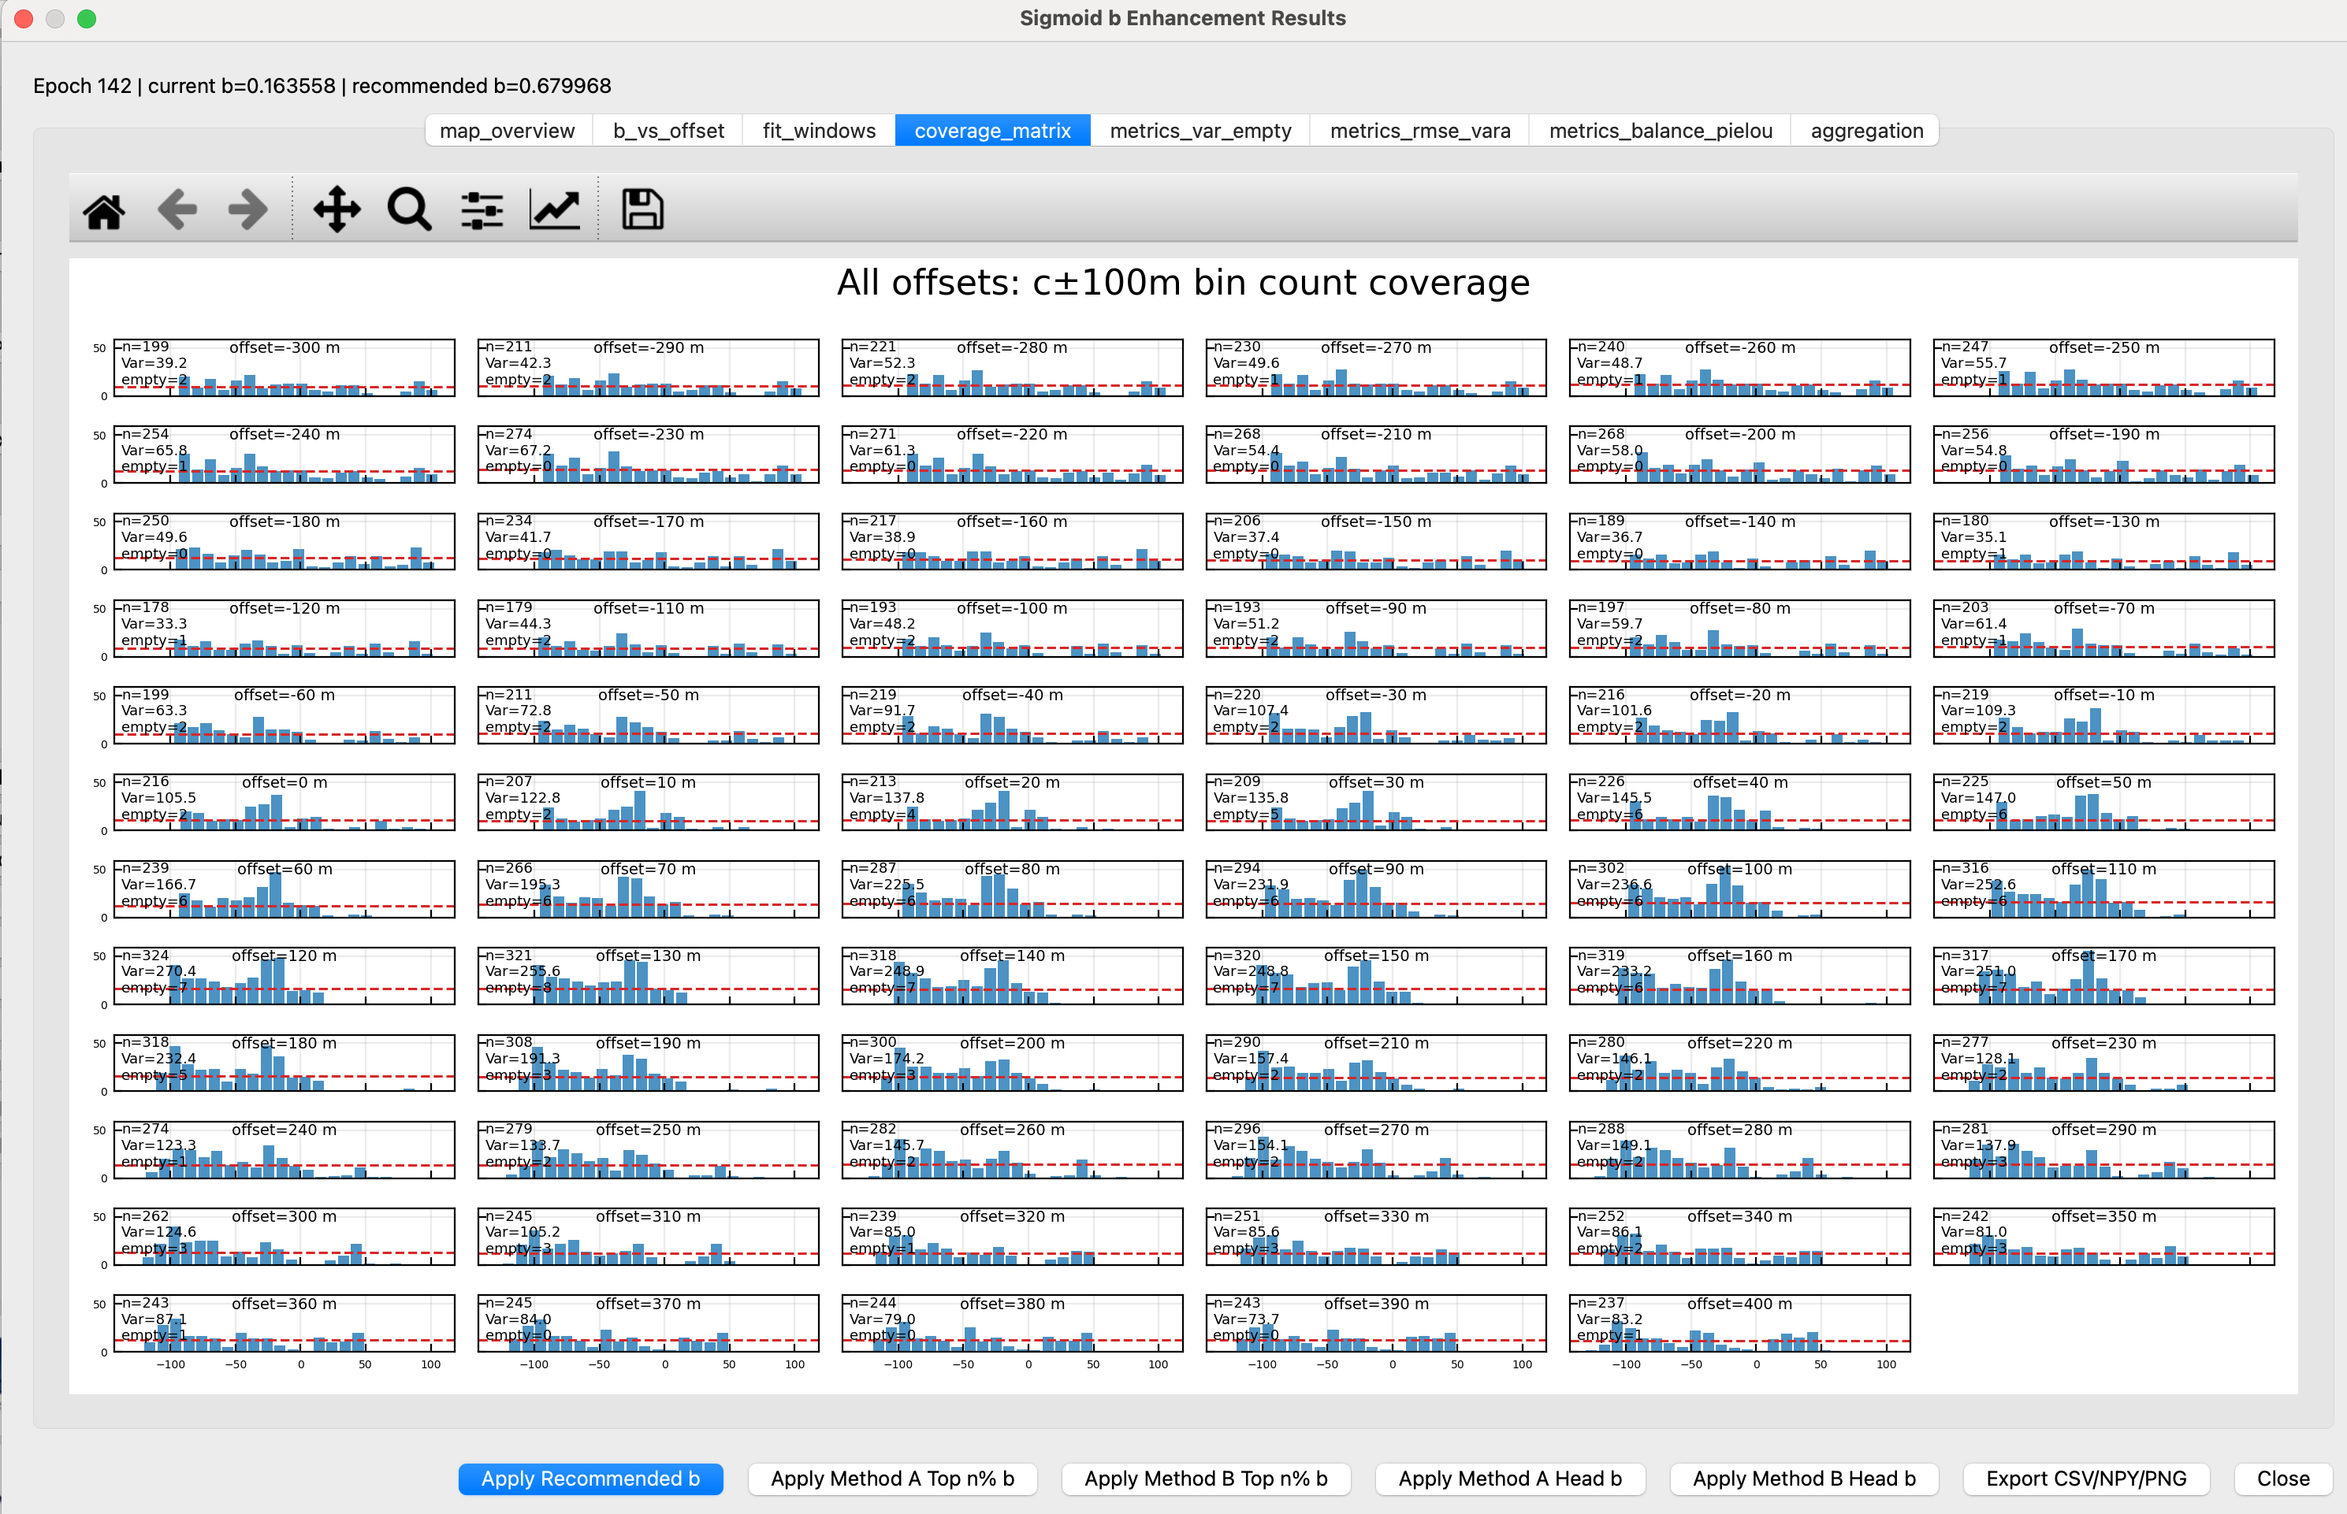

Within enhancement results, apply actions can transfer selected b values directly to the main Fit override input and trigger override application. This provides an efficient bridge between diagnostic analysis and production workflow while keeping user control explicit.
Even with one-click application, users should re-check the Fit plot before running Step 3. A recommended practice is to compare pre- and post-apply curves in the same epoch and mode.

8. Soil-Structure Interaction (SSI)
The SSI module is used to consider the soil effect when estimating pipeline displacement and strain. With SSI disabled, the pipe is assumed to follow the prescribed soil displacement directly. With SSI enabled, the solver accounts for pipe stiffness, soil restraint, friction, and local separation/contact effects, so the pipe displacement may differ from the soil displacement-particularly near sharp deformation transitions.
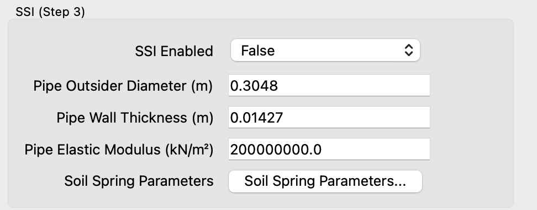

The Soil Spring Parameters dialog defines the soil parameters and numerical settings used by the SSI solver.

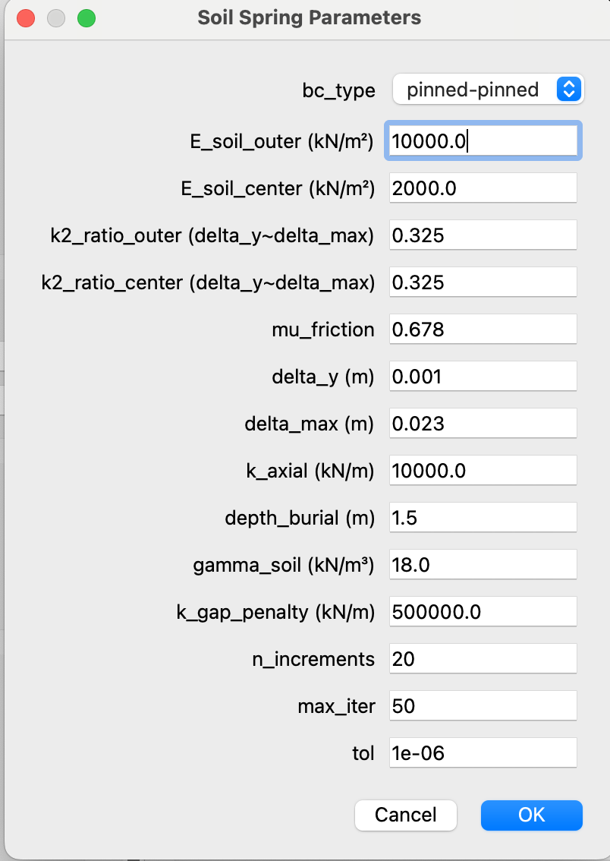

Description of each parameter:
- bc_type: Defines the boundary-condition type used at the pipeline segment ends in the SSI solver.
- E_soil_outer (kN/m²): Specifies the effective outer-zone soil stiffness used for lateral spring response outside the central fault-softened zone.
- E_soil_center (kN/m²): Specifies the effective center-zone soil stiffness used for lateral spring response within the central fault-softened zone.
- mu_friction: Sets the friction coefficient used to compute axial soil-pipe friction capacity.
- delta_y (m): Defines the characteristic yield displacement where spring response begins transitioning from initial stiffness.
- delta_max (m): Defines the displacement at which the spring force reaches its capped/plateau level.
- k_axial (kN/m): Sets the axial spring stiffness controlling resistance to relative axial slip between soil and pipe.
- depth_burial (m): Specifies the burial depth used in estimating normal confining effects for axial friction capacity.
- gamma_soil (kN/m³): Specifies soil unit weight used with burial depth to estimate overburden-related normal force.
- k_gap_penalty (kN/m): Sets the penalty stiffness used to resist compressive closure/contact in the gap-direction constraint treatment.
- n_increments: Sets the number of load increments used in the incremental SSI solution procedure.
- max_iter: Sets the maximum nonlinear iterations allowed per load increment.
- tol: Sets the convergence tolerance used to terminate the iterative solver when updates are sufficiently small.

9. Export, State, and Reproducibility
The software supports Save State and Load State for preserving the current analysis setup, including model parameters, pipeline state, and relevant interface selections. Saved states are useful for resuming calibration work, comparing parameter cases, and reproducing prior results. Save a state after establishing an acceptable fit or before testing alternative SSI, meshing, or strain settings. When loading a state on another machine or session, confirm that referenced input files are still available at the saved paths.

Export All Results creates a complete run folder for documentation and technical review. Depending on the completed workflow steps, this package may include the run configuration, numerical array outputs, CSV summary tables and diagnostics, and images from the main visualization tabs. It is the recommended export option for archiving report-relevant runs or preserving a calibration branch. Outputs associated with unfinished steps, such as strain products before Step 4 has been run, may be absent.

Export Results for OpenSRA creates a separate shapefile intended for downstream OpenSRA integration. Each feature represents one pipeline mesh element. The output includes comp_lsr for compressive longitudinal strain rate and ext_lsr for extensional longitudinal strain rate; both are stored as non-negative values. For a given mesh element, one of these fields will normally be zero, allowing compression and extension to be handled as separate channels in downstream analyses.

10. Logs and Performance
The runtime log panel provides the main record of progress, diagnostics, warnings, and errors during each analysis step. Review the log after every run, even when plots appear reasonable, because it may reveal reduced sample support, fallback behavior, coordinate-mode differences, or other conditions that are not obvious from figures alone. For troubleshooting, keep the final progress message together with the final warning or error message.

Runtime is mainly affected by the number of matched InSAR points, mesh density, uncertainty calculations, SSI computation, and field-plot rendering. Step 2 fitting and Step 3 displacement prediction usually require the most time for larger cases. For efficient testing, save the current state before changing parameters, vary one group of controls at a time, and avoid rerunning full analysis steps when only plot display settings have changed.

11. Glossary
This glossary defines key terms used throughout the InSAR Fault-Pipeline Strain GUI tool. Definitions are written for operational consistency within this manual.

11.1 Core Analysis Terms
Ascending InSAR / Descending InSAR
Two line-of-sight InSAR observation datasets from different viewing geometries. They are matched and combined in Step 1 to solve 3D displacement components.
Matched Pair
A valid ascending–descending observation pair selected by date and spatial matching rules. Matched pairs define the epoch set available for analysis.
3D Ground Motion (NEZ)
Estimated displacement components in North, East, and vertical directions computed from matched InSAR observations.
Pipeline Axis
The geometric centerline representation of the analyzed pipeline used for meshing, displacement transfer, and strain computation.
Fault Trace
The selected or fitted fault geometry used as the reference for signed-distance calculations and fit-related projections.

11.2 Fitting and Model Terms
Shape Function
A fitted functional relationship between signed distance to fault and displacement response.
Sigmoid Model (a, b, c, d)
The four-parameter function used in Step 2 for many fit paths.
- a: amplitude term
- b: transition sharpness term
- c: transition center location
- d: offset term
Fit Subset
The filtered set of matched points used for fitting, typically constrained by fitting-band geometry and quality checks.
Signed Distance to Fault
Distance from a point to the reference fault trace with directional sign. Used as the independent variable in shape-function fitting.
Fit Override
Manual replacement of fitted parameters in the Fit tab. Override values are user-specified and must be explicitly applied.
Median Fit
The baseline fitted curve (typically corresponding to the central epistemic case).
N&E Mode
Coordinate interpretation mode using North and East components.
Fault-Parallel/Perpendicular Mode
Coordinate interpretation mode using components projected relative to fault orientation.

11.3 Uncertainty Terms
Epistemic Uncertainty
Uncertainty due to limited model knowledge or parameter confidence, represented here primarily through variations in fitted b.
b50
Median epistemic b case used as the primary reference case.
b16 / b84
Lower and upper epistemic percentile cases for uncertainty envelope construction.
Epistemic Envelope
Plot region spanning selected percentile curves (for example, between b16 and b84) to visualize model uncertainty range.
b16 Floor
A configured lower bound control used to prevent non-physical or numerically unstable low-end uncertainty behavior.

11.4 Sigmoid b Enhancement Terms
Sigmoid b Enhancement
An advanced Step 2 support workflow that evaluates b across sliding windows and aggregates candidate values.
Sliding Window Fit
Local fitting operation repeated along fault trace offsets to generate a distribution of candidate parameters.
Outlier Detection
Automatic filtering process used to remove unstable local window results before aggregation.
Aggregation Method
A ranking/scoring strategy used to produce recommended b values from valid window candidates.
Head b
A leading candidate b from an aggregation method (typically top-ranked under that method’s criterion).
Top n% b
An aggregated b computed from the top fraction of ranked candidates.
Recommended b
A final suggested b summary from enhancement analysis; user may apply it manually or via one-click action.

11.5 SSI Terms
SSI
Modeling of differential response between imposed soil movement and pipeline structural displacement.
Soil Displacement
Ground-side displacement demand derived from fitted motion functions prior to pipe interaction adjustment.
Pipe Displacement
Predicted pipeline response after optional SSI transfer effects are applied.
Transition Zone
Spatial region where displacement changes rapidly; SSI effects are typically most visible in this zone.
Soil Spring Parameters
Parameter set controlling interaction stiffness/transfer behavior in SSI calculations.

11.6 Displacement and Strain Terms
Pipeline Displacement
Predicted displacement profile along the pipeline axis for a selected mode and epoch.
Displacement Field
Spatial visualization of displacement values mapped to mesh node or element representations.
Axial Strain
Axial strain component along the pipeline axis.
Bending Strain
Strain component associated with curvature change of the pipeline axis.

11.7 Export and State Terms
Save State / Load State
Mechanism to persist and restore analysis configuration, runtime state, and key UI context.
Export All Results
Comprehensive export pathway that writes config, arrays, tables, and figures to a run directory.
Export Results for OpenSRA
Targeted shapefile export pathway for mesh-based downstream use.
Mesh Element
A segment-level discretization unit of the pipeline axis used in field rendering and OpenSRA export.
comp_lsr
Compression longitudinal strain-rate attribute in OpenSRA shapefile export (non-negative channel).
ext_lsr
Extension longitudinal strain-rate attribute in OpenSRA shapefile export (non-negative channel).

